**FRIDAY, 9 FEBRUARY 2024**

Dear parents and carers,

We are definitely back into the full swing of school, it has been a terrific start to the year. Thank you to those of you who were able to come down on Tuesday for the community breakfast.  We understand that it isn’t always easy for everyone to get into school each day as children find it hard or are anxious about school. We encourage clear and open communication with us at the school and to reach out if you need support in the mornings to transition your child into school. We provide bus pick-ups on request for Tuesday and Thursday mornings where necessary, so please call if you require that help and we are able to support first thing in the mornings as well. In addition, I would like to ensure parents are aware of some of our key people in leadership or administration roles that you may or may not know. These people play key roles outside and inside of the classroom and contribute to the strategic and operational components of the school. Over the next few weeks, I will be providing photos and blurbs of these people in our school. This week we are starting with our Community and Engagement Coordinator, Cate Robson and Deputy Principal, Amanda More.

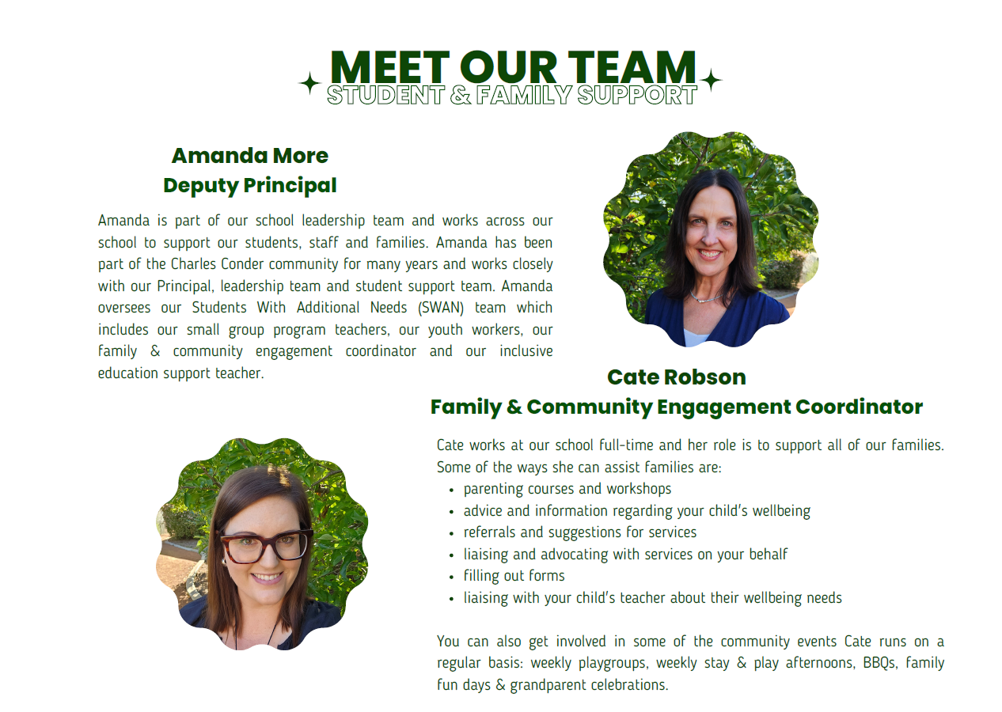

**SCHOOL BOARD PARENT REPRESENTATIVE NOMINATIONS**

I would like to take this opportunity to welcome parents and carers to consider options or interest in a school board position. I have provided a brief outline of the role of School Boards and welcome parent nominations, via completion of the nomination form attached and return to the front office by Friday, 26 February. The school board meets once a term, and it is a unique opportunity to work in collaboration with myself and other parents to oversee and support the strategic directions of the school. Please read below for more information and ring the front office if you wish to discuss or would like more details.

School boards work in partnership with the principal and school community. They have specific responsibility for endorsing and overseeing the strategic direction and priorities of the school; monitoring and reviewing school performance; developing, maintaining, and reviewing curriculum; and approving budgets and policies for the effective use of school resources; and management of financial risk. School boards provide robust forward-thinking governance at the local level to ensure that schools meet the present and future needs of their school community. School boards are supported by the Education Directorate to ensure that their responsibilities are fulfilled effectively.

**21st CENTURY INQUIRY CONCEPTUAL FRAMEWORK**

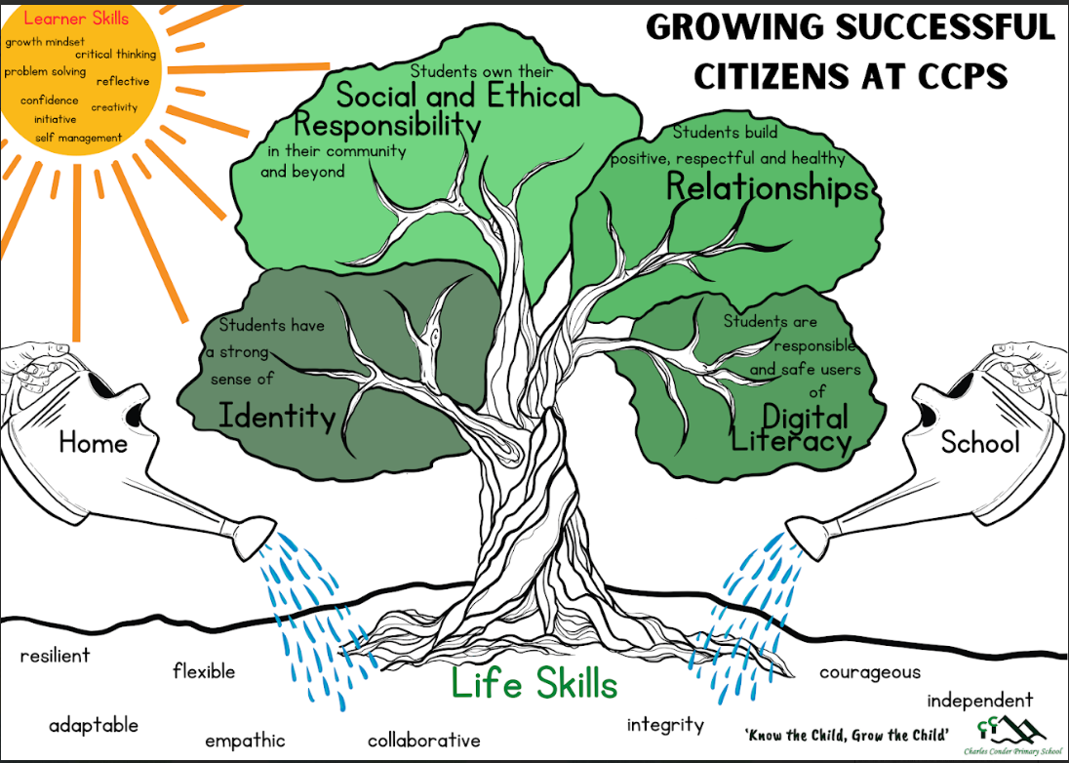The aim for the new conceptual framework is to support teaching and learning, making authentic connections to the General Capabilities and Australian Curriculum learning areas for students in each area of the school, aligning to the school’s PBL expectations, the Assets and Dispositions (learning habits) and PITW (Play is the Way) methodology. This visual below paints a picture of the Four Conceptual Lenses and dispositions that we will be exploring throughout the year. The school is starting with the concept of Identity.

**GETTING TO KNOW YOU INTERVIEWS**

Today and next week teachers will be communicating via Seesaw to capture a time and day in week 4 (19th – 23rd February) to do your getting to know you interview for children/parents in years 1 – 6. This year these conversations will have a focus on a meet and greet (face to name). We would like a focus from parents regarding what is your perspective on your child as a learner, what do they see as their child challenges/interests and teachers will discuss key learning focus areas for semester 1 and best ways for communication that suits for parents.

***Jason Walmsley***

Principal