FRIDAY, 22 JULY 2022

ATHLETICS CARNIVAL AND FIELD EVENTS
Wow, what an amazing effort from all students participating in the carnival today. We were fortunate with the weather and it was encouraging to see parents and carers come and attend and support the running of the events. We would like to thank the Lanyon Little Athletics and the Year 10 Lanyon High students for the operational support with technical equipment and practical hands on today. A big thank you goes to Mr Tucker for his organisation for the event and the numerous staff members who have various roles through the day.
We look forward to next Friday where students from years 4 – 6 can opt in to participate in the field events held at Banks oval. Please see attached information for those eligible students.
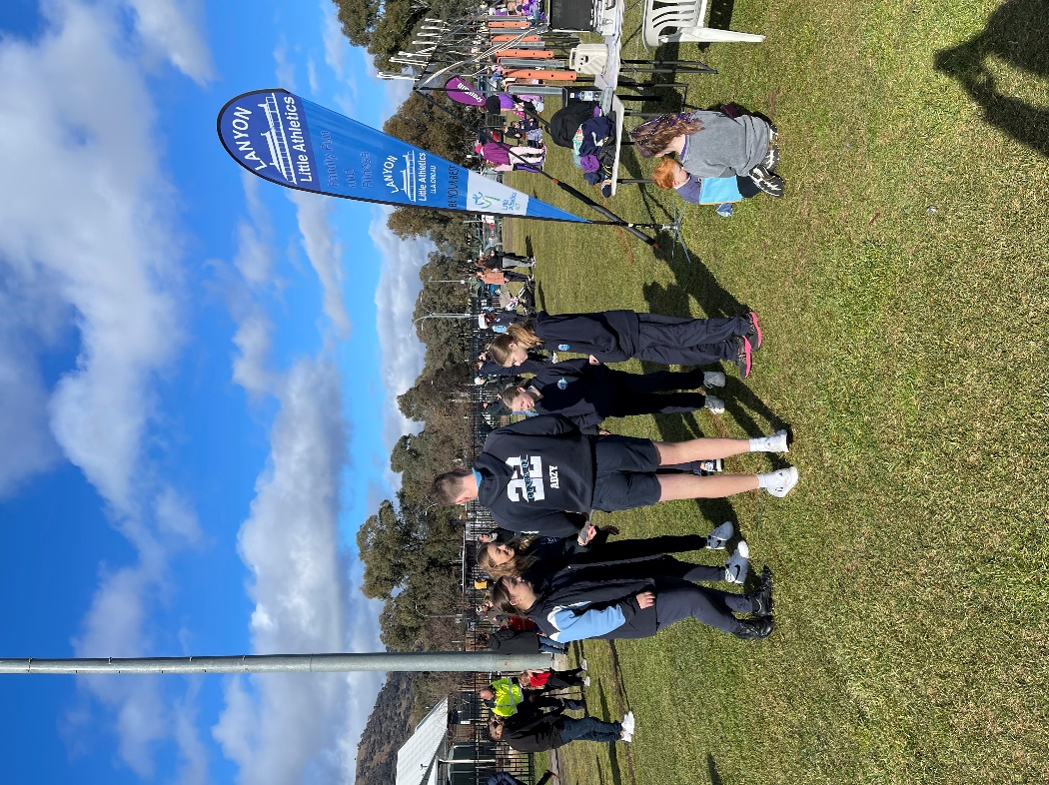
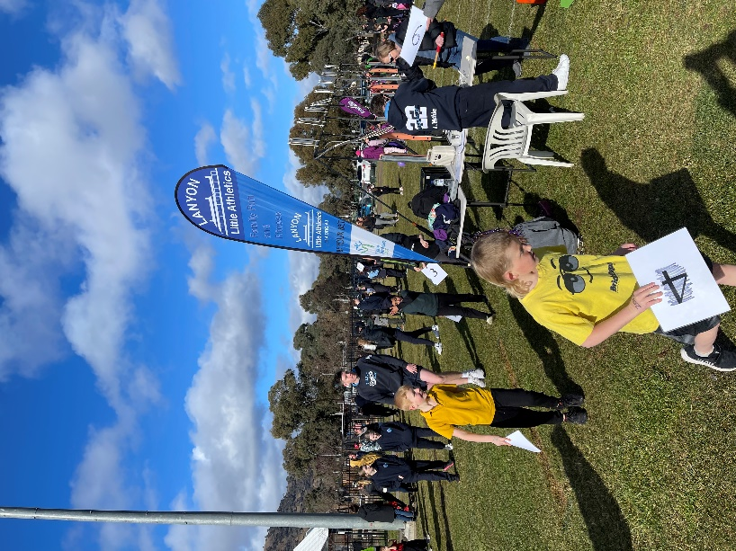

COVID MEASURES UPDATE
I’d like to welcome back all students and families for the start of term 3. This is a reminder of the letter that was provided to all families last week. In preparation for term 3 please see the below information about COVID-19 safety measures that has been provided to me by the Directorate.
You would be aware the ACT has been experiencing high levels of respiratory illness, with significant community transmission of COVID-19. The ACT Government’s priority remains to minimise the impact of COVID-19 and influenza on our community and to protect those at greatest risk of severe illness. Please be assured our schools are working to minimise any potential disruption to your child’s learning while ensuring the health and wellbeing of student and school staff.
LEARNING IN TERM 3
The ACT Government’s priority continues to be ensuring high quality learning for all students, regardless of the public health situation. While face-to-face learning in the classroom will remain the core way students learn this term, there may be times where they will do some of their learning a little differently.
We expect COVID-19 will continue to impact schools and may limit the availability of teachers. When we are unable to support students in the classroom as a result of staff availability, there may be the need to learn online for a short time, either from home or in a supervised setting at school. We have the programs, skills, and technology to do this well and our schools have been planning to enable learning to be delivered in a number of different ways.

We know families need some level of predictability, so as much as possible, you will be given notice ahead of time if your child may be required to learn at home. As always, students who can’t stay at home for any reason can still come to school and will be supervised while undertaking the same online learning activities as their peers.
We are committed to being open and transparent with our families through this journey and we value the support received from our school community to date.
RAPID ANTIGEN TESTS (RATs)
Rapid Antigen Tests (RATs) will continue to be available at our school and will be provided to staff and students on an as needed basis. You will only need to report a positive COVID-19 case to us if your child attended school during their infectious period. Parents and carers must report a positive RAT to ACT Health and follow their advice about quarantine arrangements. Please use the link provided to request RA Tests. https://forms.gle/PGeNwsUSRwRGjz1Q7
STAY COVID SMART
The best way to prevent and prepare for illness, including COVID-19 and Influenza, is to ensure you follow ACT Health’s recommendations:
- Stay up to date with COVID-19 and influenza vaccinations. This is the best way to protect yourself from severe illness.
- Stay home if you are unwell and get tested for COVID-19. Do not attend school campus if unwell or if you have tested positive to COVID-19.
- Practise good hand and respiratory hygiene. While masks are no longer mandatory except for in some settings/situations, ACT Health does strongly encourage their use particularly during this period of increased COVID-19 and Influenza cases. Masks and hand sanitiser are available at our school.
If your child is a household contact, they may still attend school as long as they do not have any symptoms and have tested negative for COVID-19. Please follow ACT Health advice and also let our school know.
WELLBEING
There is no doubt that COVID-19 has been disruptive to our lives. The wellbeing of our students, teachers and school staff remains a priority. If you or your children are experiencing increased levels of stress and anxiety, we encourage you to view the supports available on the ACT Education website.
TERM 3 PLANNING DAYS
Lastly, I’d like to remind you of the two pupil free staff planning days across ACT public schools to give teachers time for lesson planning and admin work they can’t do while on class.
These dates are Friday, 5 August and Friday, 9 September.
Students who can’t stay at home on these days will be able to attend school for supervision and general learning activities. Thank you again for your support as we navigate this challenging time. To keep up to date on how COVID-19 is being managed in ACT Public Schools, visit the ACT Education website.

5 YEAR EXTERNAL REVIEW

From Monday, 1 August the school will be hosting a panel of reviewers who will be evaluating the schools 5-year strategic plan. This is carried out by the Australian Council of Educational Research alongside two ACT Principals. As part of this review, parents are invited to meet with the review team on Tuesday 2nd August from 2.45pm to provide an example of parent views on the school. If you wish to participate in this opportunity, please ring the front office to confirm. There are no expectations, but I’m obliged to ask the parent community to participate. If you have any questions, please ring and speak with myself.

CANTEEN NEWS

The canteen is open on Wednesday, Thursday and Friday for lunch and recess. Lunch orders need to be placed by 9am each day either on Flexischools or by visiting the canteen.
Please see attached the updated Snack Shack Menu.

Jason Walmsley
Principal

