FRIDAY, 24 MARCH 2023

HARMONY DAY
Harmony Day at Charles Conder is a celebration that recognises our diversity and brings together Australians from all different backgrounds. It’s about inclusiveness, respect and a sense of belonging for everyone. Throughout the day children have been exploring a range of different cultures that are within each classroom. This focus to explore other cultures doesn’t finish today, as we are inquiring into our Multicultural Community throughout the year as you can see in this small snapshot.
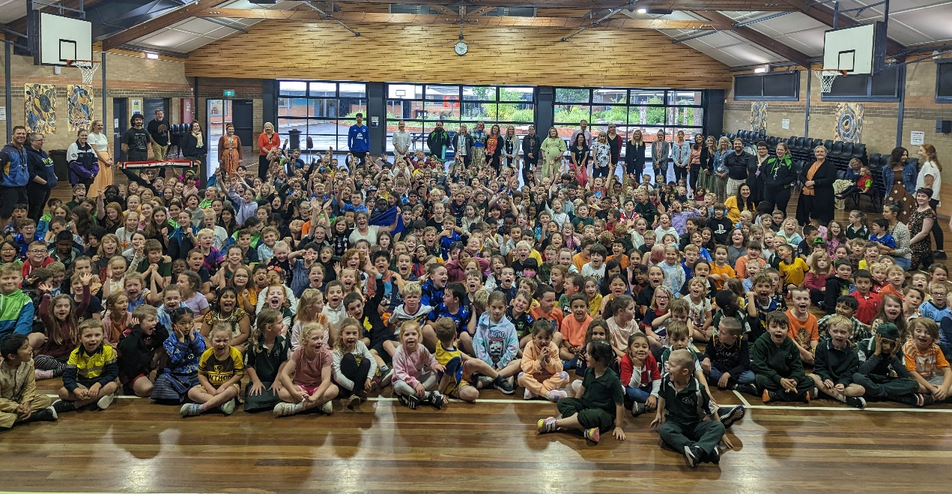

SCHOOL IMPROVEMENT PLAN 2023-2027
This plan establishes a strong improvement agenda to be driven by school leaders over the next five years. It was informed by the Directorate’s Future of Education and Set up for Success strategies alongside system-level and school-based analysis of Multiple Sources of Evidence (MSoE). Our school improvement planning is grounded in evidence from research and practice and expressed in terms of improvements in measurable student outcomes. Explicit five-year targets for improvement have been set and will give life to monitoring, evaluation and communication of progress to teachers, families, and students that align with our Vision, Mission and Values.

Our Vision
Charles Conder Primary School’s manifesto is embodied by ‘Know the Child – Grow the Child’. With students at the centre, our vision is to empower our students to learn and achieve, experiencing high quality teaching practices that promote learning and wellbeing, equipping them with the knowledge, skills and dispositions for life-long learning. Charles Conder Primary School has a strong commitment to providing a safe and respectful environment where positive relationships are fostered. Our strength lies in building collaborative partnerships between our students, staff, parents and the wider community to cultivate social wellbeing and academic achievement.

Our Mission
In our quest to engage, empower and develop 21st century learners and citizens, we believe promoting a growth mindset lies at its core with students taking on challenges and learning from them. We holistically cultivate curious, creative and well-rounded students, who have a positive self-concept and have the courage to participate and persist when stepping into the unknown. We equip students with the knowledge and skills needed to approach learning as inquirers so that they can positively contribute to the wider community today and into the future.

Our Values
At Charles Conder Primary School our community believes in the manifesto of ‘Know the child, Grow the child’. We incorporate a holistic, inclusive and collaborative approach to teaching and learning where students belong, feel safe and supported and have high expectations for success. Learning is student centred, differentiated, authentic and inquiry driven. Teachers analyse data to identify purposeful, personal learning goals allowing for targeted teaching and learning. Feedback and reflection facilitates ongoing learning, ensuring students feel empowered to take risks, extend their thinking and develop a growth mindset.

Our school priorities are encapsulated by these two statements and the details can be read in the attached 2023 School Improvement Plan:
- Improvement in the personalised growth of academic outcomes for all students
- Grow the personal and social capabilities of all students; as empathic citizens and life-long learners

FATHERING PROJECT BIKE RIDE EVENT
A couple of years ago, Charles Conder Primary school became the first ACT school to launch this project. We see and value the impact dad’s and father figures have in our children’s education. Since Covid we have had a few barriers but the school, along with a group of dads, are re-engaging with the Fathering Project. Research shows that schools that specifically target fathers will see better outcomes for students. When fathers participate in school activities, meetings and events, children enjoy school more, are less likely to have behaviour issues and are more likely to participate in extracurricular activities. Children are also more likely to engage better in school and perform better academically.

We would like to invite dad’s and father figures to join us on a bike ride with their child from the school down to Gordon Park on Friday, 31 March. For children to be involved they must have a parent with them.

The dad’s group will be organising other events throughout the year. We will be holding a scavenger hunt and an afternoon BBQ at Gordon Park. We encourage dads to come along, have some fun and meet other dad’s and also find out more about the project and the next event.

COMMUNITY & ENGAGEMENT COORDINATOR PROGRAMS: TERM 1
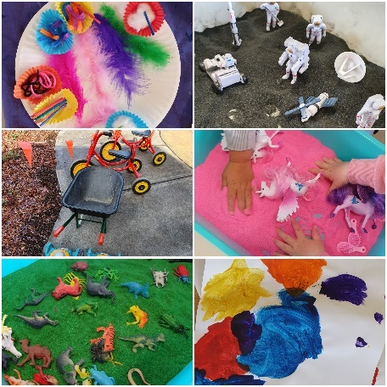
The new school year has been a busy time in the family and community engagement space. Our highly popular playgroups are now back up and running twice a week, on a Tuesday and Thursday morning. Children and their caregivers who attend playgroup can enjoy a range of activities including painting, craft, dress ups, sensory play and the preschool playground. Another regular and popular activity for our families to come and enjoy is our stay & play which is on a Wednesday afternoon. Many families enjoy this time to play outside without devices and engage with other families. Both of these programs run all year, throughout the school terms.

We have almost completed this term’s Circle of Security parenting course. The current participants have provided positive feedback about the course and the opportunity to connect with other caregivers experiencing similar parenting struggles. We offer a parenting course each term so keep an eye out on Seesaw and our Facebook page for future groups.

We have trialled a new program this term, our anxiety skills group. This is a 4 week psychoeducation program for children and their caregiver to learn some basic skills for managing generalised anxiety. We have trialled this program with the Whatley cohort and next term we will be offering it to Tanner students. This will also be advertised on Seesaw and on our Facebook page so keep an eye out if you are interested.

Maple, our school wellbeing dog, is now attending twice a week. She has a timetable of different classes she spends time in and she has been assisting in some short social and emotional lessons. One of these lessons is around body language and being safe. We used Maple as our example of what our own body language might communicate and how e can read others’ body language to help them feel safe and respected.
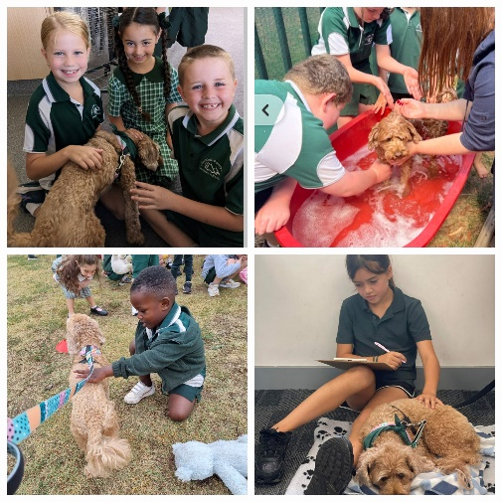
Our youth workers run multiple programs across the school for many of our students. They have been supporting students with emotion regulation skills through the ‘Zones of Regulation’ program and ‘Play is the Way’. They also run a variety of different groups that encourage student engagement and develop life skills.

This year we are also focusing on collecting and collating meaningful data on our student support and wellbeing programs to measure our impact on the school community and our students’ needs in particular. We welcome feedback and will be making adjustments to our programs accordingly.
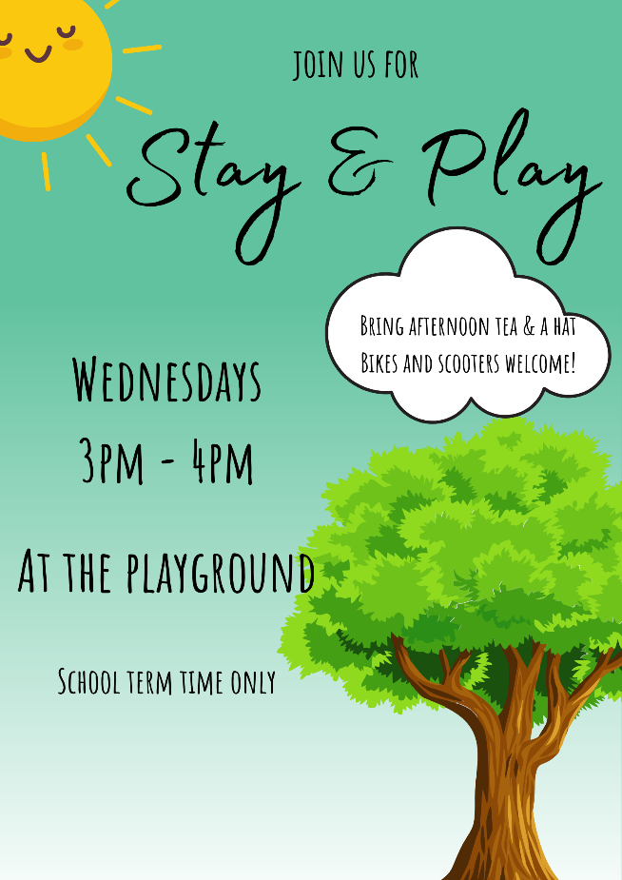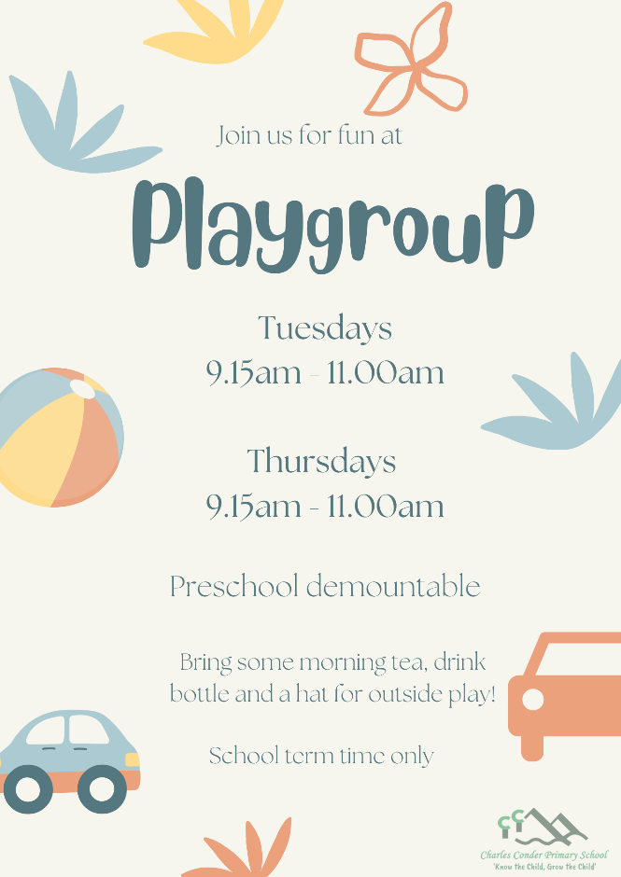

EARLY LITERACY READING WORKSHOP
Our school has organised a workshop to help you learn how to support students with reading. We will be starting our Home Reading Program in Week 10, which involves borrowing home readers each week to practise reading skills at home. We would love if you can attend the Reading Workshop, as this will provide you with the skills and strategies to help your child to become an effective reader. The Reading Workshop is targeted specifically to Kindergarten parents and it will be an informative and practical workshop. There will be some lucky door prizes and a light afternoon tea.
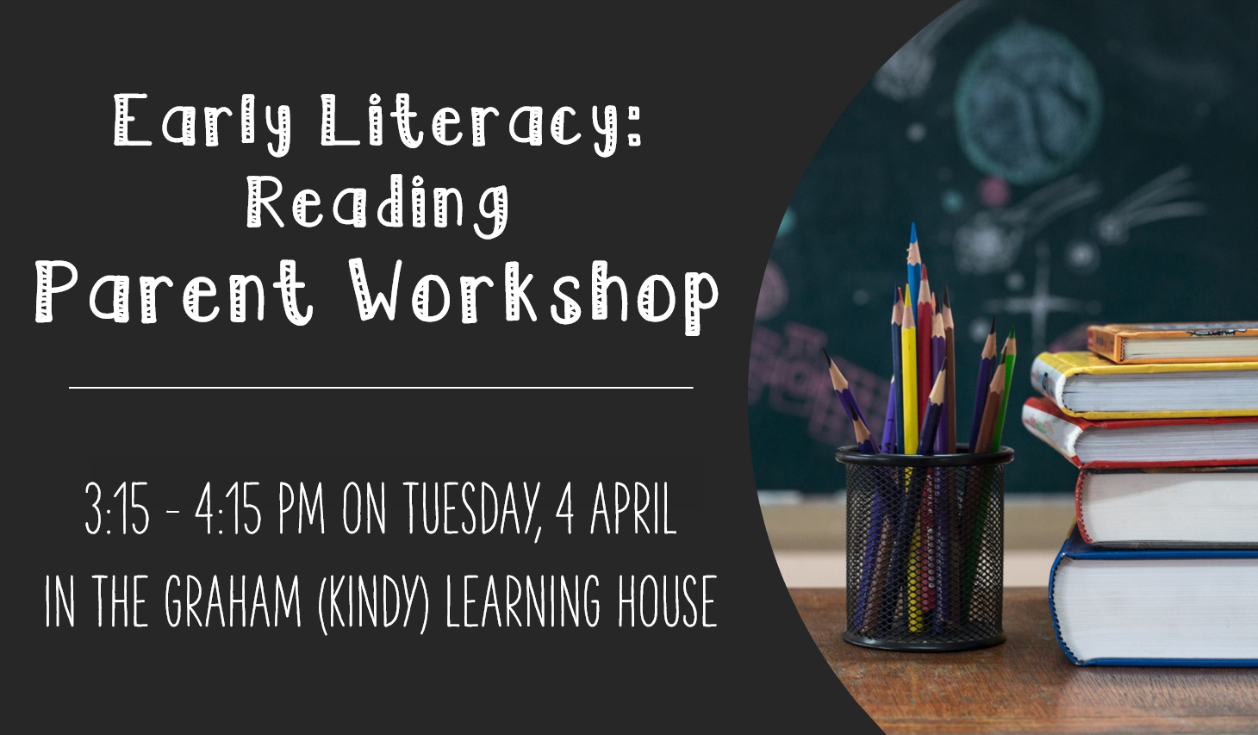

FREE PARENT & CARER eSAFETY WEBINARS: PRE – YR 12
The Directorate’s eSafety Education team offer free parent and carer information webinars about supporting children with online safety throughout the year. These webinars include understanding the current eSafety issues experienced by our young people, supporting children to be safe online, resources for handling online issues, and where to go for further support. All ACT public schools should advertise these webinars to families using these resources to encourage participation:
- Parent and Carer eSafety webinar flyer (PDF and JPG) - This can be shared via email or school newsletter and has a link and QR code with the RSVP form and webinar dates
- Parent and Carer eSafety webinar social tile (JPG) - A condensed version of the webinar flyer can be dropped into your school’s social feed (Facebook, Twitter, Instagram, Sentral, Seesaw etc.) or newsletter. Schools can personalise the tile with their school logo in the transparent white space in the top left corner.

Jason Walmsley
Principal

