FRIDAY, 23 FEBRUARY 2024

Dear parents and carers,
It has been wonderful to see so many of you come along this week where possible, as part of our Getting to Know You interviews. These conversations really do put a face to a name and set the scene for the learning ahead for the year. Through this week on seesaw, you will see each Learning House has posted an overview of the learning to be expected. All classrooms are well into the learning and new beginnings are happening which can bring its challenges. If you are new to our school, starting a new year level or building or do struggle with shyness or anxiety it can be difficult. We understand these challenges with any child and will always make adjustments to support.
Through our Social and Emotional learning (Play is The Way) we explore the Life Raft Concept BE BRAVE; PARTICIPATE TO PROGRESS. This concept provides us with the language and prompts to step into the unknown which can be uncomfortable, but the braver you are the more you can learn. Stick at it and each day will get easier!!

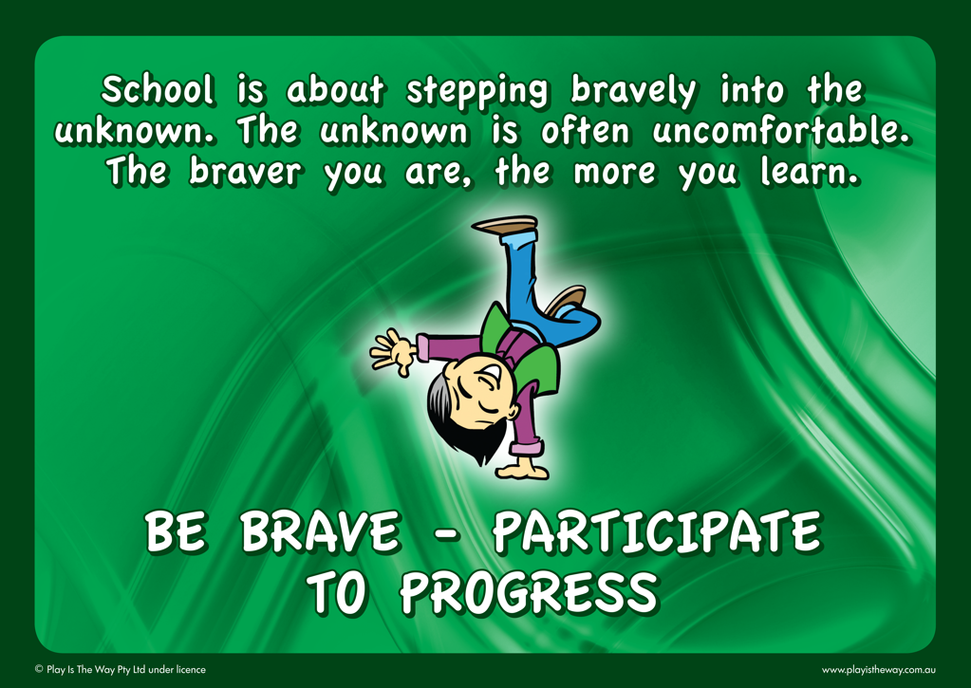

SCHOOL BOARD NOMINATIONS CALL
I would like to take this opportunity to welcome parents and carers to consider options or interest in a school board position. I have provided a brief outline of the role of School Boards and welcome parent nominations, via completion of the nomination form attached and return to the front office by Friday, 1 March. The school board meets once a term, and it is a unique opportunity to work in collaboration with myself and other parents to oversee and support the strategic directions of the school. Please read below for more information and ring the front office if you wish to discuss or would like more details.
School boards work in partnership with the principal and school community. They have specific responsibility for endorsing and overseeing the strategic direction and priorities of the school; monitoring and reviewing school performance; developing, maintaining, and reviewing curriculum; and approving budgets and policies for the effective use of school resources; and management of financial risk. School boards provide robust forward-thinking governance at the local level to ensure that schools meet the present and future needs of their school community. School boards are supported by the Education Directorate to ensure that their responsibilities are fulfilled effectively.
This will be the final nominations call before next Friday. Please ring the front office on 6142 0177 or come in and have a chat if you are interested.

TERM CALENDAR
Please find attached the calendar of upcoming excursions and events at our school.

FRONT OFFICE ADMINISTRATION STAFF
This week we are highlighting the front office staff who are key operational faces in the school. You may know the voice or face of Lauren or Haley but read more below about the aspects of their roles in our school.

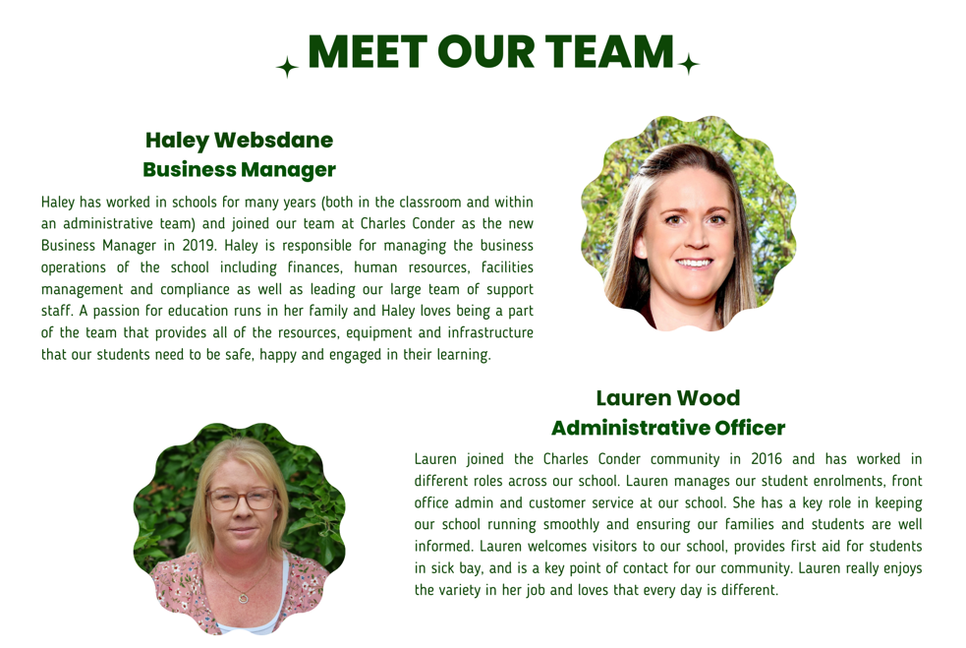

Jason Walmsley
Principal

