THURSDAY, 16 JUNE 2022

PUPIL FREE DAY REMINDER
The ACT Government is supporting all ACT public schools to hold two staff planning days during term 2. These days will provide public school teachers with some extra time to complete student reporting and additional planning for semester 2. These days will correspond with the Local High School to support families in the local area.
Our school will hold the second staff planning day on: Wednesday 22nd June 2022.
Where possible, we ask that students do not attend school on this day. Students who can’t stay at home will be able to attend school and be supervised by minimal relief staff while undertaking general learning activities.
Please confirm via phone on 6142 0177 or email info@conderps.act.edu.au if your child will be attending school on this day. If you have any further questions about our staff Reporting and Planning days, please reach out to our front office and speak with myself.

2023 ENROLMENTS
Its not too late to enrol your child or young person at an ACT public school. Enrolments remain open throughout the year, so apply online now to receive an offer for the 2023 school year. It’s not too late to enrol for 2023.
If you forgot to enrol your child or young person in an ACT public school for next year, don’t panic. Enrolments remain open throughout the year. You can find out more information and apply online. Support is also available from our school or by calling the Enrolments Telephone Service on 6205 5429.

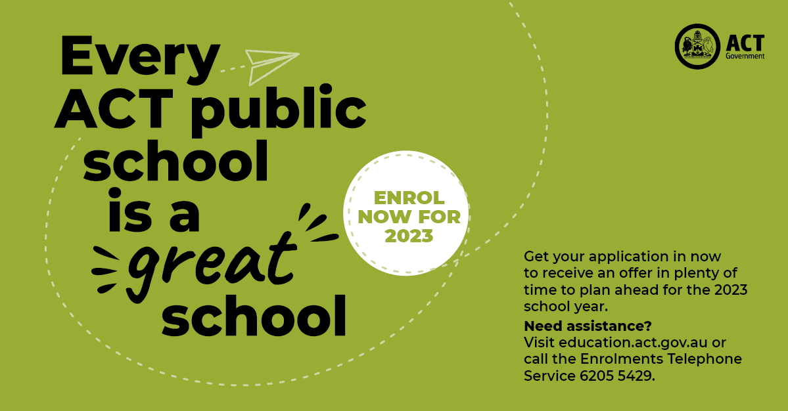

SEMESTER 1 REPORTS
This semester students from years K – 6 will receive a digital copy of their child’s report based on the Australian Curriculum via email on Thursday, 23 June. If your contact email has recently changed, please contact the front office to ensure you receive your child’s report. Preschool students will receive a paper copy of their students’ progress aligning to the Early Years Learning Framework from Friday, 24 June. Students from years 1 – 6 will receive an A-E grade that illustrates progress against the year long Achievement Standard of each curriculum area taught. Below I have outlined some detailed key information of the Achievement Standards and A-E reports. Your child may receive an S grade which means that due to significant absences the teacher is unable to provide a grade for this semester. As always if you have any questions or would like to discuss your child’s report please ring or communicate with your child’s teacher via Seesaw to make an appointment.
As part of the reports, you may have comments regarding your child’s efforts towards the Assets for Life which describes the key learning habits that we teach throughout all curriculum areas. These include, Self-manager, Collaborator, Researcher, Thinker and Communicator. In addition, some comments may refer to the Play is the Way games which is a new approach to developing students Social and Emotional Capabilities.

The Australian Curriculum specifies the knowledge, understanding and skills to be taught and learned within a given subject area from kindergarten to year 10. Each content area is accompanied by an Achievement Standard. Achievement Standards refer to the quality of learning (the depth of understanding, extent of knowledge and sophistication of skill) demonstrated by students within a given subject. Teachers use Achievement Standards at the beginning of a learning period to find out what skills and knowledge individual students bring to a new topic, and then to select the most appropriate content to teach. Teachers also use the Achievement Standards at the end of a reporting period to determine what each student has learnt in relation to the Australian Curriculum.

The Australian Curriculum is designed to be both achievable and challenging and the Achievement Standard for each subject and year group outlines the high level of achievement expected of students. A national approach requires all States and Territories to report student achievement using a 5 point rating. In the ACT, student achievement in Years 1–9 will be reported using the letter ratings A–E, where a ‘C’ rating indicates that a student is performing at the standard expected of students in that year group.
To provide a universally consistent base for school/teacher judgement of student learning across all ACT K - 10 schools, the “C grade” will indicate that the student has demonstrated satisfactory achievement of what is expected against each Achievement Standard. The learning standard described by each of the Achievement Standards embodies high expectations of learning achievement. To be awarded a “C” grade using these standards represents a significant achievement.
How will Semester 1 reports differ from those issued at the end of Semester 2?
The Australian Curriculum Achievement Standards describe the expected student achievement after being taught the curriculum for the entire year of schooling. The semester 1 A-E System Report will reflect student progress towards the end-of-year Achievement Standard. The semester 1 grade reflects the level to which a student is ‘on-track’ in achieving their final grade. The semester 1 report is now called a “Progress Report”. The semester 2 A-E System Report is summative, and the grades allocated indicate the overall achievement the student has made. This judgment is based on evidence gathered by the teacher throughout the entire year.

CELEBRATION ASSEMBLIES
In week 10, our classes will be providing an opportunity for families to attend two celebration assemblies where classes will be sharing their learning about the Inquiry in the Natural World and other aspects. The K – 2 assembly will be on Thursday, 30 June and the assembly for Years 3 – 6 on Friday, 1 July starting at 9.15am in the hall. Due to on-going COVID restrictions regarding density requirements and physical distancing indoors we ask that only two representatives from each family attend the assemblies.

F.A.C.E INTIATIVES
Charles Conder is proud to be a Fathering Project school. The Fathering Project recognises that fathers, and father figures, play a vital role in children’s lives. The evidence demonstrating fathers’ potential to positively influence their children’s health and mental health, social success and academic achievements is now robust, indisputable, and compelling. Following the successful launch of the project in our school last year we are excited to be offering other opportunities for fathers and father-figures to spend quality time with their children this year. The first of these is a family fun day to be held at the indoor pool at Lakeside Leisure Centre in Tuggeranong. This is a free event open to all Charles Conder families.
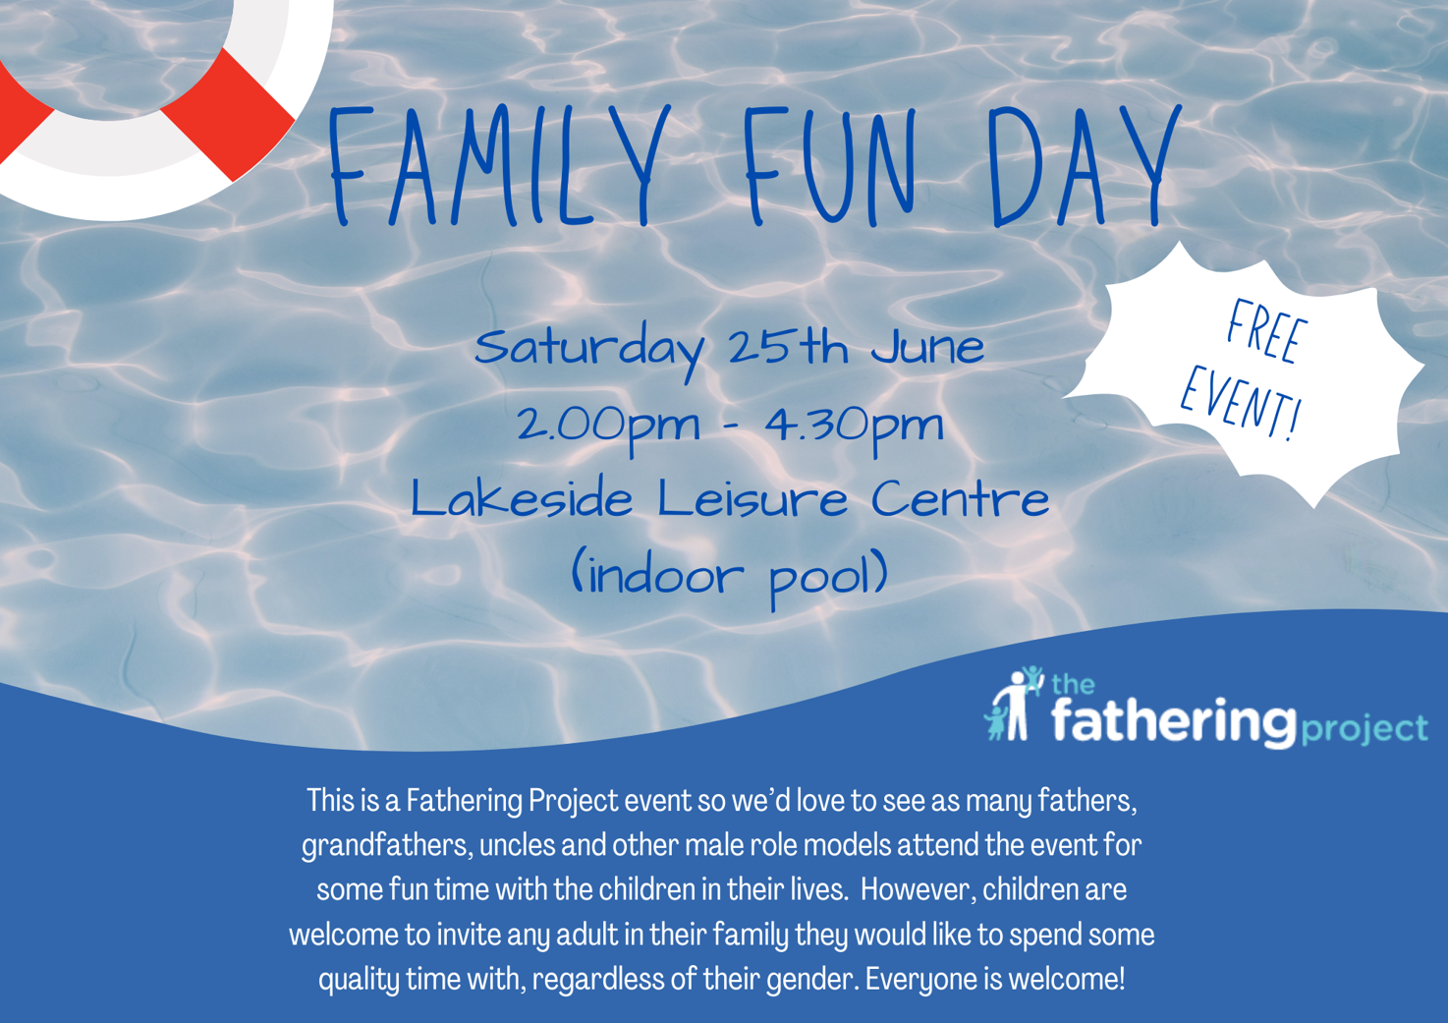

WELL BEING DOG
We are excited to announce that we are getting ready to welcome our wellbeing dog Maple to our school. Please see the information flyer attached for more details.

PARKING SAFELY AT CHARLES CONDER
As our school at Charles Conder grows, managing traffic and road safety is a matter for everyone in the community. Children are more at risk in road environments around our school because they are smaller and less visible to drivers. Their behaviour can be less predictable than adults and they may have errors of judgement when dealing with traffic. School environments are often congested during the peak times because roads and carparks aren’t built to meet the high demand and struggle to cope over a short timeframe. I’m working in collaboration with the Education Directorate to create some car parking solutions for Charles Conder. The school community can help to reduce congestion and improve safety for children by walking or riding to school. If you need to drive, consider part way drop off or collection points and follow these traffic management guidelines to ensure children remain safe. Here are some additional safety tips at drop off and pick up times. These will also be shared via Facebook.
Failing to follow simple road rules like parking on verges, in no stopping zones, in bus stops, near children’s crossings, on footpaths or across driveways increases the risk to children around schools. Please do the right thing to create a safe environment around our school.
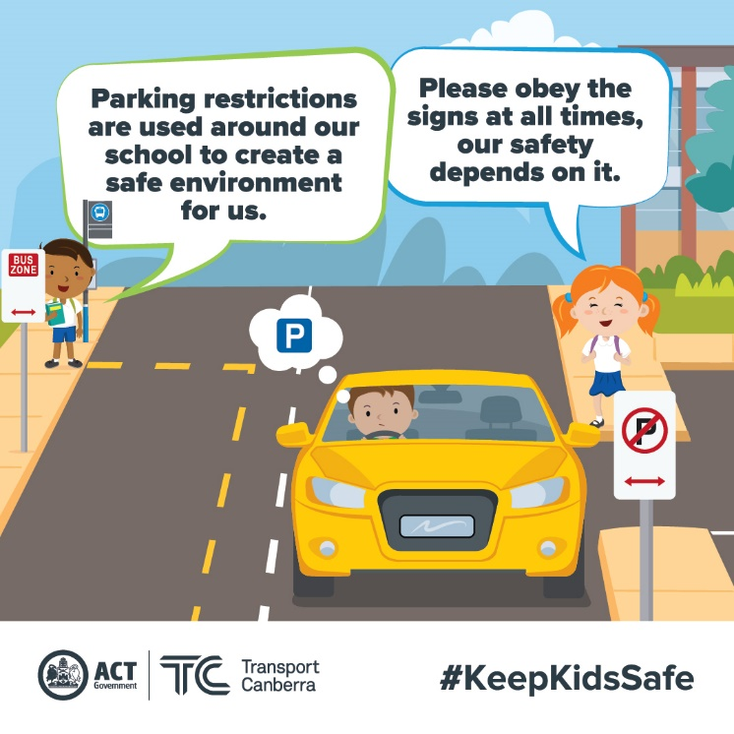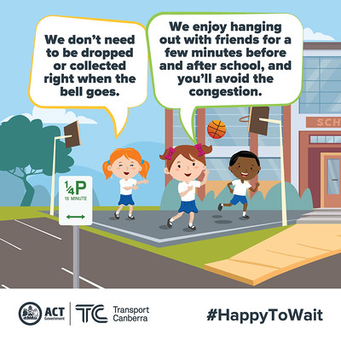

SCHOOL PHOTOS
We have been lucky enough to secure our school photographer for an additional session next week to take portrait photos of students and staff who were absent last week. On Friday, 24 June the photographers will be able to take portrait photos and sibling photos of students who missed out last week. We will be sending home a google form for you to complete if your child/ren were absent last week and you would like an opportunity for them to have a photo taken. Please complete the form as soon as possible so we can send this information through to the photographers.

Jason Walmsley
Principal

