TUESDAY, 31 MAY 2022

RECONCILIATION WEEK
The National Reconciliation Week 2022 theme, “Be Brave. Make Change.” is a challenge to all Australians— individuals, families, communities, organisations and government—to Be Brave and tackle the unfinished business of reconciliation so we can Make Change for the benefit of all Australians. Last year Reconciliation Australia encouraged all Australians to take action; not just in National Reconciliation Week, but every week of the year.
This year our Inquiry learning has been focusing on Connecting and Caring for our Natural World. Students are investigating our dependence on a healthy natural environment, investigations focus on the diversity and richness of the natural environment and the ways in which humans use and interact with the environment. Importantly, this lens emphasises the need to care for and live responsibly with the environment - at a local, national and global level. Learning is also happening whereby classes are exploring how Aboriginal and Torres Strait Islander communities maintain a social connection to and take responsibility for country and place.
Next week the school will be fortunate enough to have an amazing Incursion with a highly experienced Indigenous performer, Dion Drummond. He will be sharing a wealth of knowledge exploring Indigenous traditions, through storytelling, songs and dance. These sessions will occur on Tuesday and Thursday next week with no cost to families.

MORIMOTO CAMP
The Year 5/6 group are heading to Jindabyne next Wednesday. It sounds like it is getting chilly down south. Most families have completed all necessary registration and permission forms. Please use this as a reminder to ensure you have all things in place and are ready to go next Wednesday 8th June. Teachers will provide an update later this week on Seesaw for departure time.

RAPID ANTIGEN TESTS
The Education Directorate is still only providing Rapid Antigen Test kits on request and we are still receiving parent requests for these online via this link: https://forms.gle/PGeNwsUSRwRGjz1Q7
If you would like Rapid Antigen Test’s for your children, please complete the Google form each week via the link above, and these will be distributed to students on Friday afternoons.

SCHOOL PHOTOS
Please see the below information regarding school photos on Monday, Wednesday, and Friday next week.
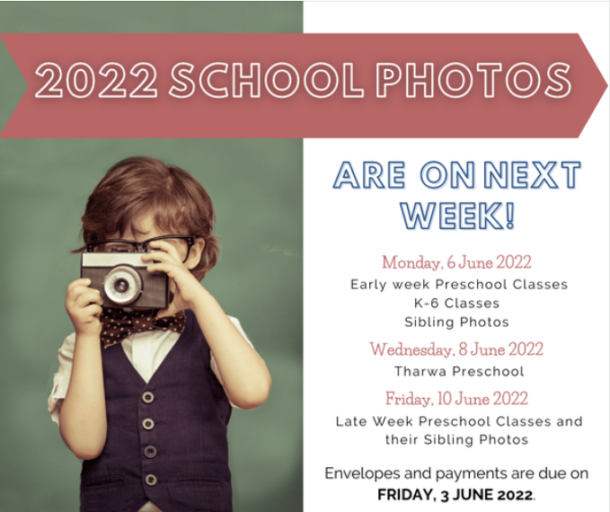

IMP PRIMARY CONCERT BAND
I would like to congratulate the three amazing students below who have been selected into these Primary Concert Bands identified in the table below. What an outstanding achievement, Josh, Lily and Alex!!
These ensembles are directed and administered by the Instrumental Music Program and rehearse each school week at the Instrumental Music Program Centre in Kaleen. The ensembles will perform at school, community and directorate events throughout the year. Some groups also participate in interstate tours.

Joshua | Payne | 6 | Primary Concert Band | Charles Conder Primary School
Lily | Cuttriss | 6 | Primary Concert Choir | Charles Conder Primary School
Alex | Samuels | 6 | Primary Concert Band | Charles Conder Primary School

CELEBRATION ASSEMBLIES
During the last week of school this term we will be providing some opportunities for parents and carers to come into school and be part of some celebration assemblies. We normally have 3 of these a term to share the learning of different parts of the school however, due to the current COVID restrictions it is making it difficult to have these frequently. We hope into next term this will change. We will advertise later in the term the specific dates and times for your child’s Learning House.

CANTEEN OPERATIONS
Starting this week, the Whatley children will be able to do over the counter sales at their lunchtime break from 10.30 – 11am. Please keep an eye out on Seesaw for this notice. The lunch ordering process for Canteen ordering hasn’t changed, and this will be online as normal. We would like to also remind parents and carers that if you are able to spare some time to volunteer the canteen always needs your help. Please ring the front office to get more information. The children in years 3 – 6 will continue to do over the counter sales as their break time is different.
BREAKFAST CAFE
Next week starting Monday, 6 June, our Breakfast Café will open again in the Community Hub. This operates from 8.40 – 8.55am everyday where any student can come along and have breakfast and READ a book. This term our Youth Workers Justin and Kieren will be supported by our fabulous Student Leadership Group. If parents would like to come in and read a book with their children that is okay as long as it is on the outside benches at the moment.
The Community Hub is connected to the Library building (Learning Hub) and is located opposite the Kindergarten building.
Just a reminder that our gates will be open however, classrooms won’t operate until 8.45am

Jason Walmsley
Principal

