FRIDAY, 16 FEBRUARY 2024

GETTING TO KNOW YOU INTERVIEWS
Next week (19th – 23rd February) we are having the getting to know you interview for children/parents in years 1 – 6. This year these conversations will have a focus on a meet and greet (face to name). We would like a focus from parents regarding what is your perspective on your child as a learner, what do they see as their child’s challenges/interests and teachers will discuss key learning focus areas for semester 1 and best ways for communication that suits parents.

SCHOOL BOARD PARENT REPRESENTATIVE NOMINATIONS
I would like to take this opportunity to welcome parents and carers to consider options or interest in a school board position. I have provided a brief outline of the role of School Boards and welcome parent nominations, via completion of the nomination form attached and return to the front office by Friday, 26 February. The school board meets once a term, and it is a unique opportunity to work in collaboration with myself and other parents to oversee and support the strategic directions of the school. Please read below for more information and ring the front office if you wish to discuss or would like more details.
School boards work in partnership with the principal and school community. They have specific responsibility for endorsing and overseeing the strategic direction and priorities of the school; monitoring and reviewing school performance; developing, maintaining, and reviewing curriculum; and approving budgets and policies for the effective use of school resources; and management of financial risk. School boards provide robust forward-thinking governance at the local level to ensure that schools meet the present and future needs of their school community. School boards are supported by the Education Directorate to ensure that their responsibilities are fulfilled effectively.

CAR PARK SAFETY
During our return to school routine as our school grows, we are faced with the on-going problems of car park spaces at drop off and pick up times. I understand that parents are forced to park in grassed areas at times, but I would like to remind parents that they need to be extra cautious at these times. My observations suggest that parents in general are extra cautious, and I appreciate your diligence, however there are some who feel frustrated and are expressing this to parents and staff. Parents need to be aware that if you are being troubled by drop off and pick up times please come and speak with myself. Any parent that is confronting others with their concerns need to be aware of their responsibilities of their safety and others and I will address this with them. As previously stated, most people are being careful and are showing patience and ensuring the safety of children.

MEET OUR TEAM
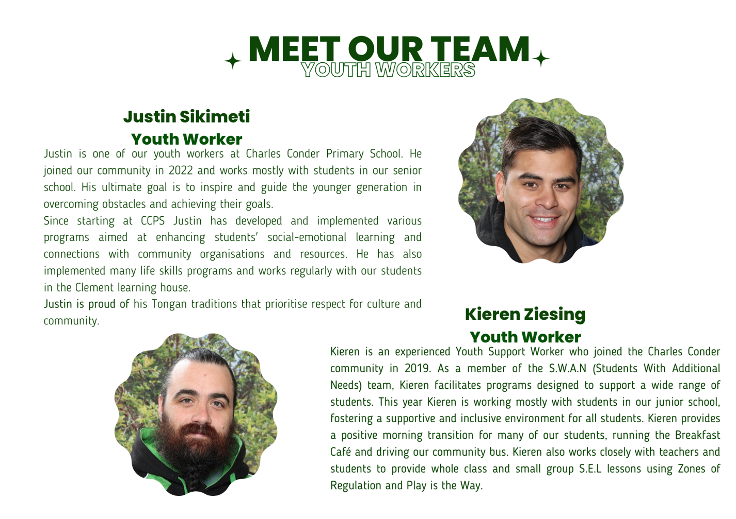

PARENT WORKSHOPS
The Education Directorate Psychology team are providing two parent workshops addressing: your child’s strong emotions and your child’s anxiety avoidance. These two sessions are available to any parents in government schools. Please see attached information regarding venues, dates, and times.

P&C ANNUAL GENERAL MEETING

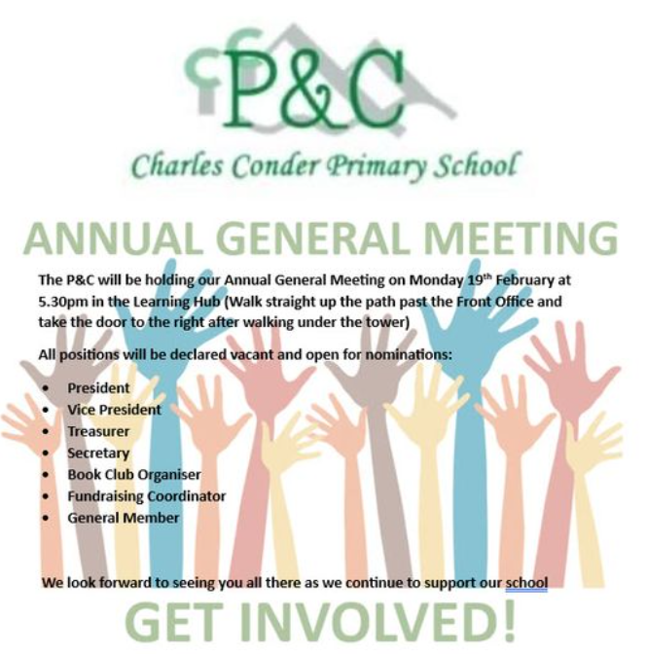

Jason Walmsley
Principal

