**FRIDAY, 4 AUGUST 2023**

Dear Parents and Carers,

As we continue to dive into this term it has been refreshing to have the sun shining and some glimpses of spring in the air. As you can see on the term 3 calendar, we have a busy schedule of events spread throughout. We really enjoy the opportunities to connect with families and provide our students a range of extra-curricular learning experiences. There was no better example of this than our Athletics Carnival last week and the celebration of the Women’s Soccer World Cup Matilda Day yesterday. It was awesome to see loads of parents and children playing soccer together yesterday afternoon across the school oval with three fun and competitive soccer matches of parents versus children. The students also enjoyed the class and soccer games during the day as well. We would like to give a big thank you to Tuggeranong United Football Club for their generous donation of equipment that was presented at our Tuesday morning assembly.

**BOOK FAIR**

Next week there is a Scholastic Book Fair operating in the Learning Hub from Tuesday to Friday with opportunities before and after school to purchase books for your children. We know instilling a love of reading is so important in the early years and this unique chance to grab a book through Scholastic helps the school with more resources as well. Please see the poster attached for more details.

**ACTIVE AFTER SCHOOL SPORT**

We are excited to offer our students the opportunity to participate in our K-2 After School Multisport Program for Term 3, 2023 totally free of charge. The school has partnered with Gecko Sports and the program requires participants to commit to weekly, non-competitive clinics with a strong emphasis on encouragement, inclusion and participation. This program offered this week is already full for children in K – 2 and if you were lucky enough to secure a place, you received an email yesterday. We are seeking some additional days with Gecko Sports later in the term if you missed out on this opportunity. Unfortunately, the spaces are capped at 30 students for each session. Stay tuned for more options later in the term.

**MAKERS EMPIRE SCIENCE ENRICHMENT**

Earlier this year Charles Conder Primary School was selected to participate in the Makers Empire Kids in Space program for 2023. Staff from the ACT Education Directorate’s Academy of Future Skills team were thrilled to be participating in the Design Thinking with a small number of schools across Canberra. Mr Boland (Science Specialist) has been leading a team of year 5/6 students throughout the first part of the year exploring and designing prototypes utilising a 3D printer on Space Junk.

They say childhood ambitions are the paths in life that will truly satisfy you. While many aren’t so lucky in following through on their dreams, there is hope for a few of the next generation to make theirs come true. *Kids in Space,*which began earlier this year, has been showing primary school children around the country what opportunities await them in Australia’s growing space industry. Eight schools in the ACT were chosen for the national education program brought together by the [Andy Thomas Space Foundation](https://andythomas.foundation/), [Australian Space Agency](https://www.industry.gov.au/australian-space-agency) and [Makers Empire](https://www.makersempire.com/). And on Thursday, 27 July at the Hedley Beare Centre for Teaching and Learning, the children showed off what they’d made over the past two months as part of the program.

Our students from Charles Conder can be seen reflecting on their journey via this link [The future is now: national program preps ACT's next generation for growing space industry | Riotact (the-riotact.com)](https://the-riotact.com/the-future-is-now-national-program-preps-acts-next-generation-for-growing-space-industry/687324) What a brilliant job they did!!

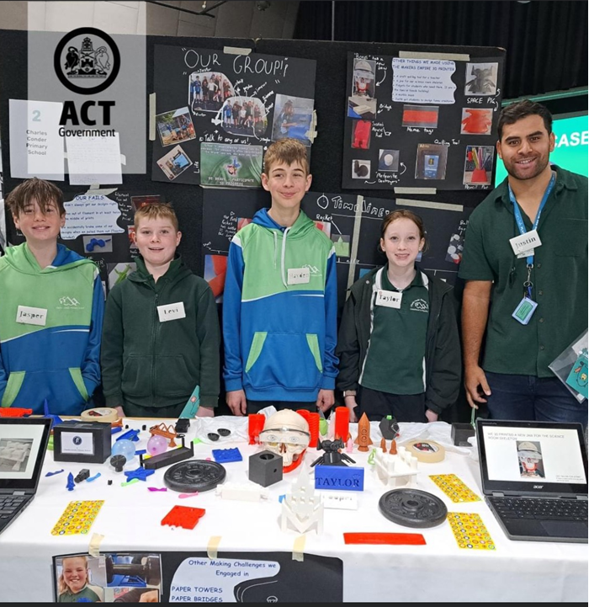

**COLOUR EXPLOSION**

Join the ColourExplosionSchoolRun4Fun and feel uplifted by the difference you can make in our school! We are looking for enthusiastic individuals to help with our incredible Colour Explosion School Run 4 Fun on Friday 25August. By sharing your time and skills, you can help us make our students have a colourful blast!

Take advantage of the AMAZING online portal that is included with our fundraiser! There are lots of interactive features, and plenty of rewards up for grabs, like free incentive prize credit. Let's make the most of our resources and start fundraising now!  Visit [www.australianfundraising.com.au](http://www.australianfundraising.com.au) to get started!

If you have a few hours available, please contact Tamara [ccpspandc@outlook.com](mailto:ccpspandc@outlook.com) to volunteer!

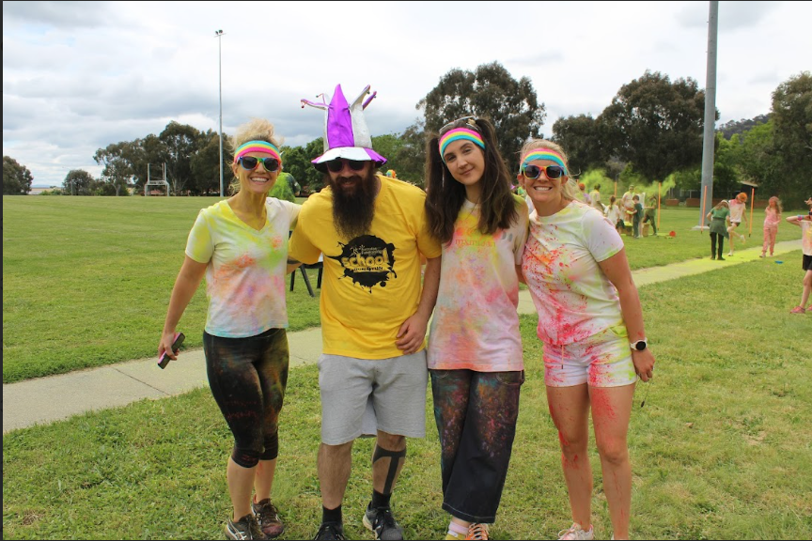

**BOOK WEEK**

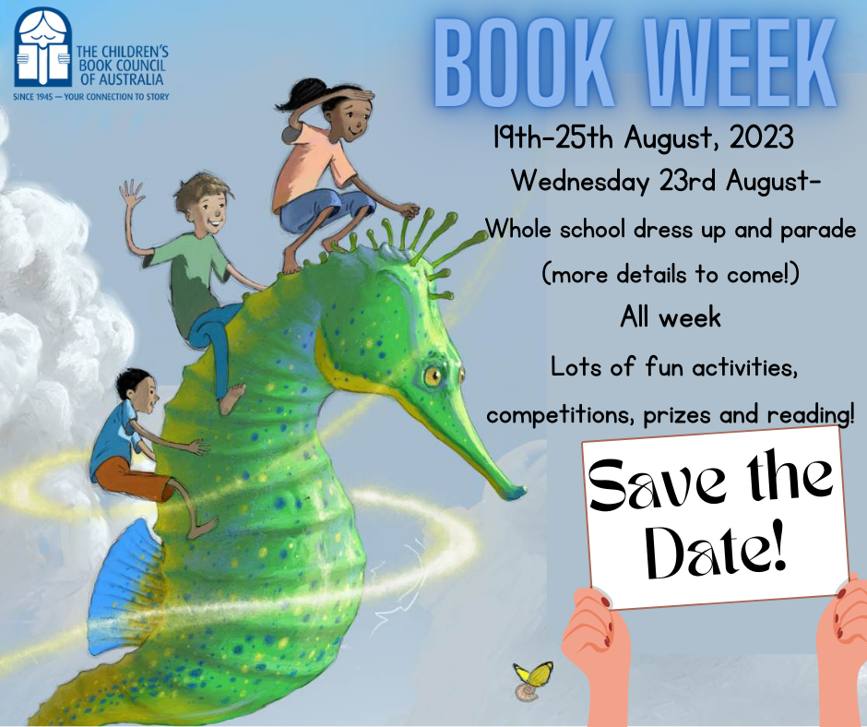

**MATILDA’S DAY SOCCER GAMES**

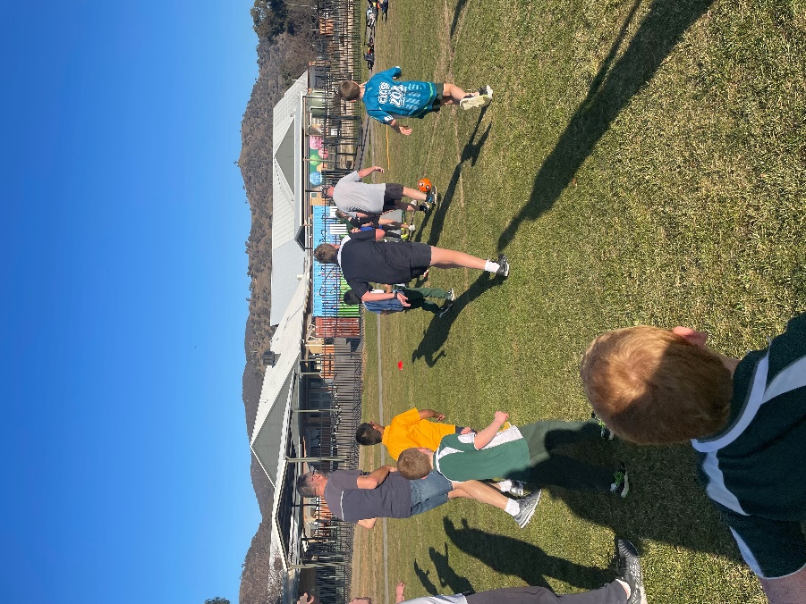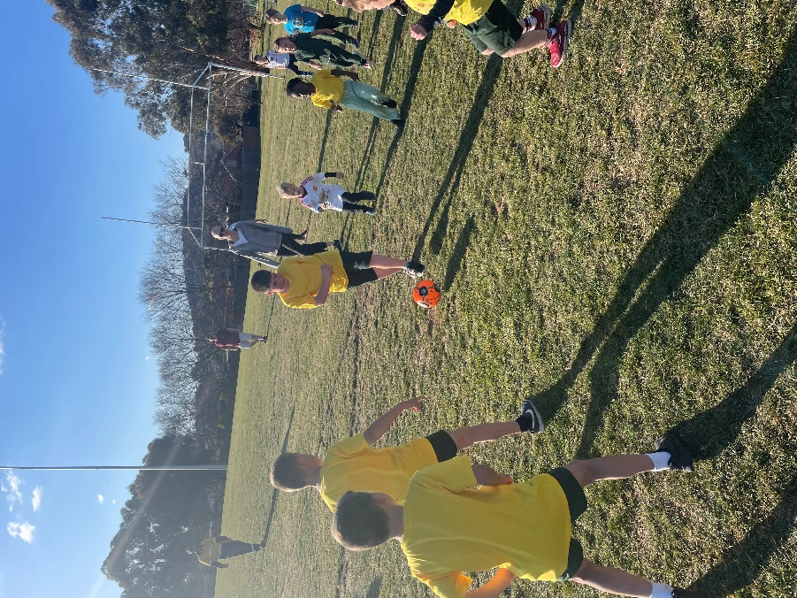

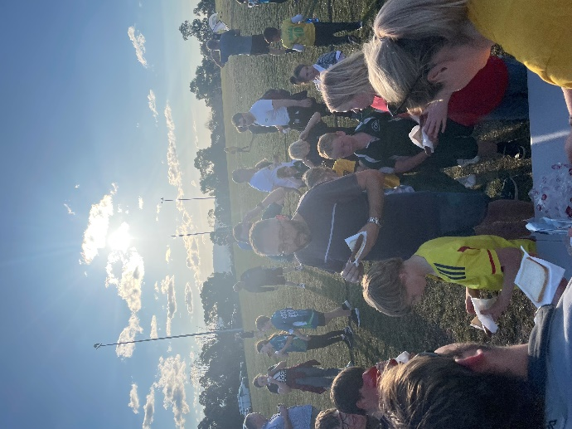

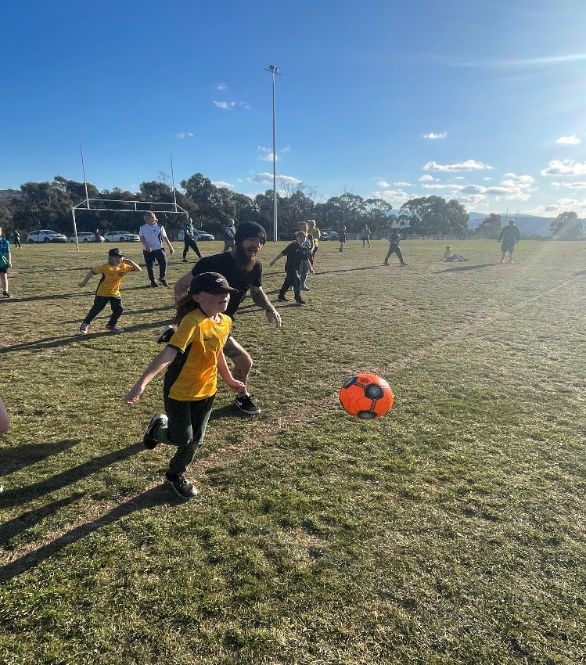

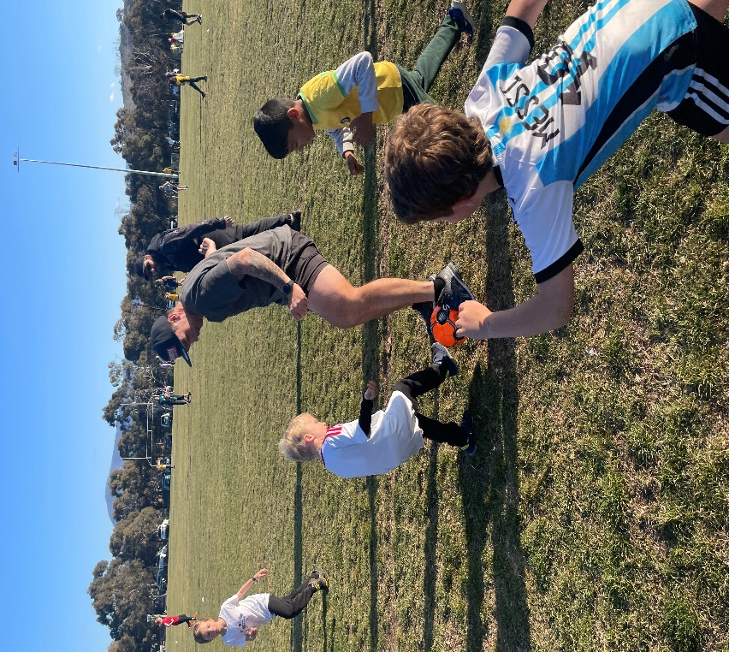

***Jason Walmsley***

Principal