**FRIDAY, 10 FEBRUARY 2023**

Dear Parents and Carers,

During the first two weeks it has been delightful to see children engaging in the beginning-of-the-year class routines and being immersed in learning across the school. This time is important for children to understand how to start the day, feel a sense of belonging in the class and connect with peers and teachers. There has been a feeling of positivity in classrooms with children quickly getting back into PBL (Positive Behaviours for Learning) Expectations and learning expectations in different buildings.

**COMMUNICATION AT CONDER**

As you would be aware the Seesaw App is a core communication tool for teachers and students to share learning and make key school announcements. All parents can access this free app and teachers have QR codes to share their classes. Next week you will have teams sharing term overviews which illustrate a snapshot into the learning areas for each term, including; English, Mathematics, S.EL, Inquiry and other key messages. We always encourage parents and carers to speak with us face-to-face and attend assemblies throughout the year to get updated information and to celebrate learning. The Principal’s Messages will provide key dates on our calendar and additional information happening in the school. Later in the term we will be providing opportunities for parents to attend celebration assemblies.

**WHOLE SCHOOL CONCEPTUAL INQUIRY CURRICULUM**

During the last few weeks teaching teams have been planning the beginning components of the Inquiry focus across the school. We have been listening to parents’ feedback in school surveys during the last year and have explored options to investigate different Cultures. The shared inquiry this semester will be centred around culture. Through our inquiry we will define what culture means to us and investigate what we each feel showcases our own culture. Together we will explore our own culture, each other’s culture and how together we create a multicultural community. This exploration may look slightly different across the school but there will be a shared focus.

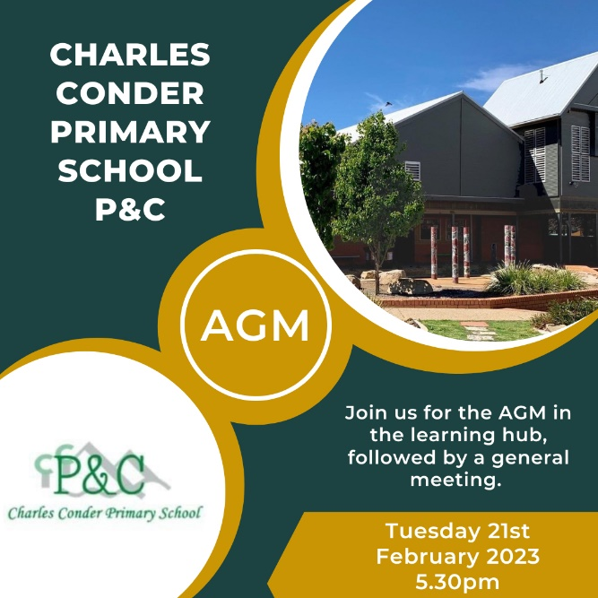

**CHARLES CONDER AND THARWA PRESCHOOL P&C AGM’S**

We are looking for parents and carers to join us at Charles Conder on Wednesday, 22 February to become part of two P&C Associations. Please see the attached flyer. This is a great opportunity to learn about how you can contribute or become a volunteer to support community initiatives and build a positive school spirit.

The Tharwa Preschool P&C are holding their AGM on Wednesday, 22 February at 12:15pm. Anyone who is interested in joining the P&C are welcome to attend.

**THREE-WAY INTERVIEWS WITH STUDENT GOALS**

During the beginning of the years the teachers and support staff are getting to know the students and shaping the curriculum and personalising the learning. A part of this process is our Three-Way Interviews whereby parent, child and teacher discuss the child’s learning and begin to develop learning goals. The community will be informed and invited into these sessions via Seesaw but not until early to mid-March.

**SCHOOL IMPROVEMENT PLAN AND PARENT COFFEE CHATS**

I indicated last year that the staff have been working on our new School Improvement Plan in term 4, 2022 and have finalised this at the beginning of this year. This is now ready to be shared with community members to have their views and opportunities to meet with myself. I will be providing an overview of this at the P&C AGM on Wednesday, 22 February and also will be hosting some Friday morning coffee chats this term. These will occur each Friday 8:30 – 9:30am starting on Friday, 17 February – and finishing on Friday, 3 March. If you are interested in learning more about the School Plan or would like an opportunity to speak with myself about any aspect of the school, please come along to any of these sessions

**EVENTS, EXCURSIONS AND PAYMENTS**

Throughout the school year, we facilitate a range of different events and activities to enrich our student’s learning. Information and permission notes for these events are sent home to families via email and include all the relevant details for the event. Please contact the front office if you would like to update your email and contact details. We ask that you please return all notes and payments for these events to the front office by the due date on the note as this allows us time to arrange for staffing and any other accommodations needed for the day.

If the event has a cost attached, payments can be made using a credit/debit card by visiting the following link: [www.conderps.act.edu.au/payment](http://www.conderps.act.edu.au/payment) and following the instructions on our Westpac Quickweb form. Alternatively, you may wish to pay over the phone or in person at the front office by EFTPOS. We appreciate your understanding that we are cashless.

Please feel free to contact us if you have any questions about an event or excursion.



**TUGGERANONG UNITED FC REGISTRATIONS**

New and Returning players are invited to contact Nicole Mitchell on [miniroos@tufc.org.au](mailto:miniroos@tufc.org.au) or Stan Mitchell on [president@tufc.org.au](mailto:president@tufc.org.au) for more information.

***Jason Walmsley***

Principal

