FRIDAY, 10 MARCH 2023

Dear Parents and Carers,

SCHOOL BOARD VOTING
This morning you would have received an email providing you with some details on voting for a parent representative for the School Board Election. Thank you to Ellen Samuels and Lisa Macdonald for your nominations.

Unfortunately, the link that was provided to us this morning was not correct, and we have now updated this in the login information below.

This year Charles Conder has 1 parent and citizens vacancy for a School Board Representative position. I have received two nominations for this position and therefore a ballot will be conducted for you to decide who will be the member on the board. I have attached a list of candidate statements for you to consider in making your vote within the email below.

Voting will open at 11am on Friday, 10 March 2023 and
voting will close at 11am on Thursday, 16 March 2023.

This year the Education Directorate has supported us to move to an online ballot. To vote you will login here: https://acteducation.au1.qualtrics.com/jfe/form/SV_4J84kZkmnRKL42y

Your login details will be:
Our school code: CONP
Your email address: (the one you received this email in)

These details will verify you are eligible to vote and only allow you to vote once. This will be a secret ballot so once you have been verified using these details, they will not be linked to the results of how you vote. If you have any issues when logging in please contact the front office and speak with Jason.

Candidate Statements
Ellen Samuels
My name is Ellen Samuels and I am mum to Lachlan, who is in year 5. We have been members of the CCPS community since my eldest son started preschool here in 2014. Since 2017, I have been a representative on the CCPS School Board, and I have been the Board Chair since 2020. I am seeking to continue in my role on the Board and will continue to do my best to represent parents and carers to work for the best outcomes for all our children.
In my work life, I manage community education and engagement programs and have spent nearly 20 years’ experience setting high-level strategic directions in this space. During my time on the board I have been proud to see the continued rollout of the Positive Behaviours for Learning (PBL) framework and I have tried to increase communication between the board and the school community, including writing a
newsletter board report after each meeting. In recent years, I have worked closely with our Principal to draw interest from our politicians and other leaders to our issues surrounding parking and underutilisation of the sporting oval next to the school. By combining my professional skills, my experiences as a parent and by listening to other parents and carers, I believe I can continue to help the school strengthen its community focus, maintain its financial position, and increase academic success to make Charles Conder the best environment possible for all our children.

Lisa Macdonald Holmes
My name is Lisa, I’m originally from England but have called Australia my home for the past 14 years. I moved to Canberra over 5 years ago with my husband Michael and our 2 boys, shortly after arriving I gave birth to twin boys. I currently have 3 children in Charles Conder and 1 in another local school. 2 of my children are in the LSU/small group programme. Having no family in Canberra or close by community is everything to us, and as a family my boys will be with Charles Conder for the next 7 years so we have a vested interest in the school and community. As a parent with more than one child with additional need I feel I will be able to bring a different view point to the board and make sure the disability community has a voice within our local community.

THREE-WAY INTERVIEWS
It has been really amazing to see parents coming into classrooms this week to have some great conversations about your child/rens learning and next steps with goal setting. We look forward to strengthening our partnership with you to build on this great start to the year. Following from this meeting you will receive a goal mat with your child’s goals and strategies to support at home. If you haven’t had a chance to meet we will continue to provide opportunities via Seesaw for next week and you can also ring to make appointments.

2023 SCHOOL LEADERS
Congratulations to our Year 6 School Leaders who have been recently selected. Charles Conder was overwhelmed with applications, and we thank all students who applied. The students will represent our school in numerous ways. Well done!

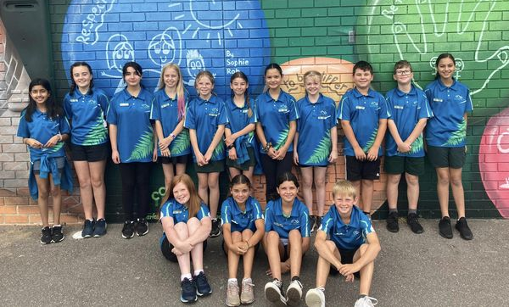
HARMONY DAY – THURSDAY, 23 MARCH
You will see a flyer attached to this message providing some details regarding our celebration of Harmony Day. This is a very important day for us to acknowledge other cultures and continue to develop our shared understanding of other cultures within our school community. One of the main parental engagement activities we are doing is to create a community Art Mural whereby parents are invited to come into the school between 8.30 – 10am or from 2 – 3pm to take part in this activity. We will also be providing a special lunch via the canteen as your children will have a flyer in their bag about that this week.

SWIMMING CARNIVAL RIBBONS
Thank you to Mr Tucker and staff for organising a running a brilliant school swimming carnival last week. Mr Tucker and other staff members are in the process of sorting out placegetters and ribbons which will be awarded to students in a couple of weeks at one of our Tuesday morning assemblies. We will notify parents when this will occur.

On behalf of the school we wish you a safe and enjoyable long weekend and a reminder next week begins on Tuesday, 14 March.

Jason Walmsley
Principal

