FRIDAY, 9 JUNE 2023

Dear Parents and Carers,

Throughout this year all classes from Preschool to year 6 have been using an Inquiry mindset to explore and learn about Our Multicultural Community. Throughout each week, classes are immersing themselves into different cultures, posing wonderings and exploring the cultures of adults in the school and their peers. It is really interesting to explore what defines our personal identity and what individuals believe and value in their culture. We definitely know that the beauty of the world lies in the diversity of its people, and these are key concepts that have led the learning in classrooms this year. During the next few weeks classes and teams across the school will be inviting parents into assemblies or learning showcases to share and celebrate their inquiry learning about My Culture and Your Culture. We look forward to sharing these experiences with our community.

FATHERING PROJECT
Last Thursday, 1 June we hosted a father’s only event where Marcus from M&K Meats in Lanyon shops delivered a presentation on the best ways to BBQ meats. It was a terrific discussion, and it was great to see fathers and father figures connect with each other, cook some meat together and have dinner.
We are looking forward to hosting the next event for Dad’s and Kids! On Wednesday, 21 June we would like to celebrate State of Origin and host Dad’s and Kids Oztag games NSW V Queensland!
From 3.30pm we will have Oztag games followed by pizzas. Come along with your Origin Colours and have some fun on the Oval from 3.30pm. The afternoon session is about having fun with your children so if you haven’t played Oztag before that is okay, Mr Tucker and Justin (youth worker) will have games set up to enjoy.
Please see attached poster for details and keep an eye out on Seesaw and Facebook. We would appreciate it if you could email RSVP by Monday, 19 June to info@conderps.act.edu.au

ENROLMENTS
Enrolments for 2024 Preschool have been open since Monday, 26 April and the first round will close on Thursday, 1 June. If you are a current family and have a child ready for preschool next year or know a family in the community, we urge you and them to enrol as soon as possible via this link https://www.education.act.gov.au/public-school-life/enrolling-in-a-public-school.
Prospective families can enrol after Thursday, 1 June and throughout the rest of the year however, we encourage you to enrol as soon as possible to receive a letter of offer. We have been overwhelmed with enquiries and we look forward to welcoming new and existing families into the preschool later in the year. If your child is currently in the preschool and you would like to choose Charles Conder for Kindergarten you don’t need to do an online enrolment just complete the transition form that your preschool teacher has provided to you and return this to your child’s teacher or the front office by Friday, 30 June 2023.

STAYING COVID SMART
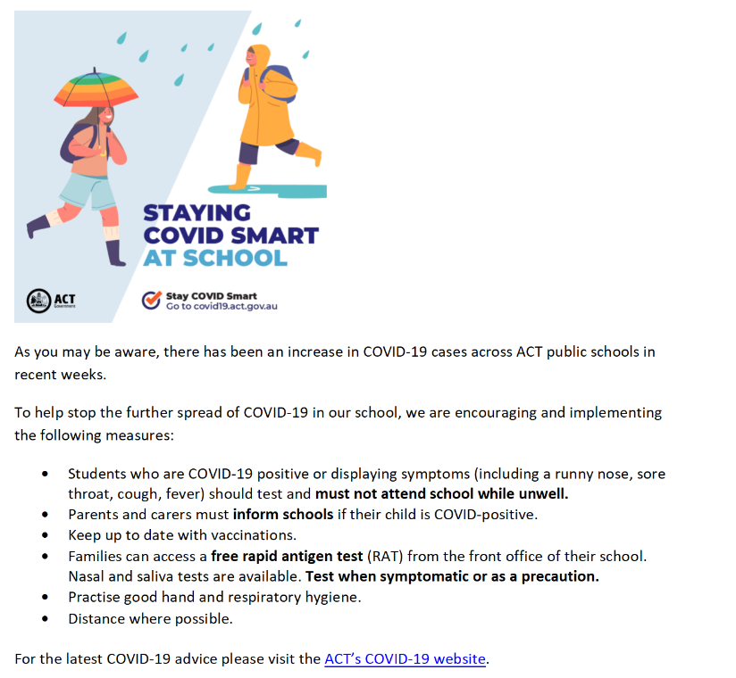

CANTEEN UPDATE
I would like to take this opportunity to welcome Jodie our new Canteen Manager to the school. It is refreshing to see some different options on the canteen menu, and we look forward to Jodie’s creativity in the future. Thanks again to Mel for her on-going work during the first part of this year. Kerry Turner is part of the canteen team, and we appreciate Kerry’s work and our dedicated volunteer Kristie Leskinen as well.
Please don’t hesitate to reach out if you wish to volunteer in the canteen.

TUGGERANONG CROSS COUNTRY
Congratulations to all of the students who competed at the Tuggeranong Cross County. We were impressed with the strength and determination of the students throughout the day. A big thank you to all parents who attended.
A special mention must go to Kirralee Evans, Beau Kesby, Bella and Georgia Lozancic who have qualified the for the State Championships.
We wish them the best of luck!

We hope all of our families have a lovely long weekend and we will see you all on Tuesday, 13 June.

Jason Walmsley
Principal

