FRIDAY, 19 AUGUST 2022

SCHOOL SATISFACTION & CLIMATE SURVEY
The 2022 School Satisfaction & Climate Survey is now open!
Dear parents and carers,
Last week I wrote to families indicating that we will be providing details to parents about the upcoming annual satisfaction and climate surveys. As part of our continuous effort to improve ACT schools, the Education Directorate invites you to give feedback in an online survey about your experience of your child’s school. Your responses will help our school to identify what it does well and how it can improve. The data will also be used to underpin school improvement practices and inform government priorities, as well as research projects and longitudinal studies aimed at improving the quality of education services in the ACT.
Today you will receive an email with login details and clear instructions on how to access the survey. Please read the email carefully. If you require the survey in a different language this can be provided by contacting the front office.
The survey will be open from today, Friday 19 August 2022.
ACADEMY OF FUTURE SKILLS EXCURSION YEAR 5/6
Academy of Future Skills

“We’re going to be building a house, you need to build it so it keeps very cool but the cold type of cool” said Mrs Linehan across the science room to 5/6TL. We got our nature journals and got two sheets of paper to design, we designed our houses then got into groups of three or four and made the houses using many different materials. Then tested the temperature of the houses using a thermometer while shining a sun light on it to see how effective each material was. Every thirty seconds we checked how different the temperature was.
As the group shuffled to the next room our next activity started, we had to make a windmill.
The first step was to get into a group and we discussed what our blades were going to look like, we chose a tear-drop shape so we got to work and started cutting.
Minutes later and we were ready to test our windmill, we tested it at least six times and if it worked, we would add more blades each time. We recorded how fast the blades were going as our answers. We all had so much fun at the Academy of Future Skills and can't wait to go back.

By Eva and Kiara

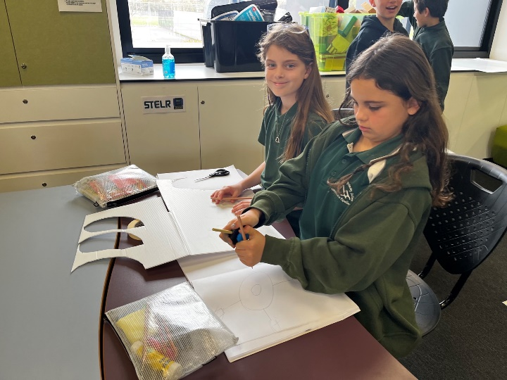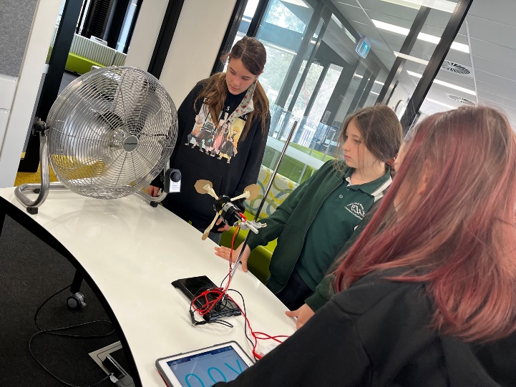
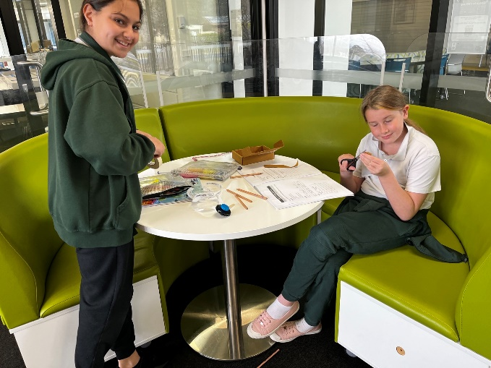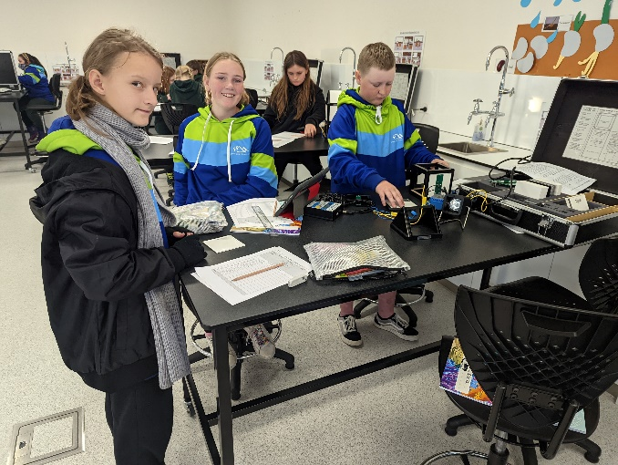

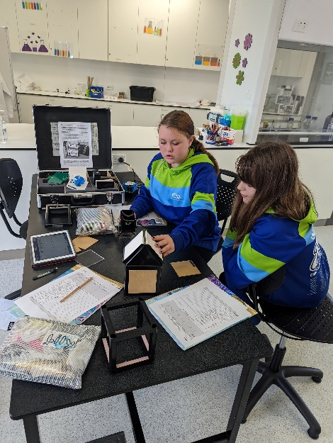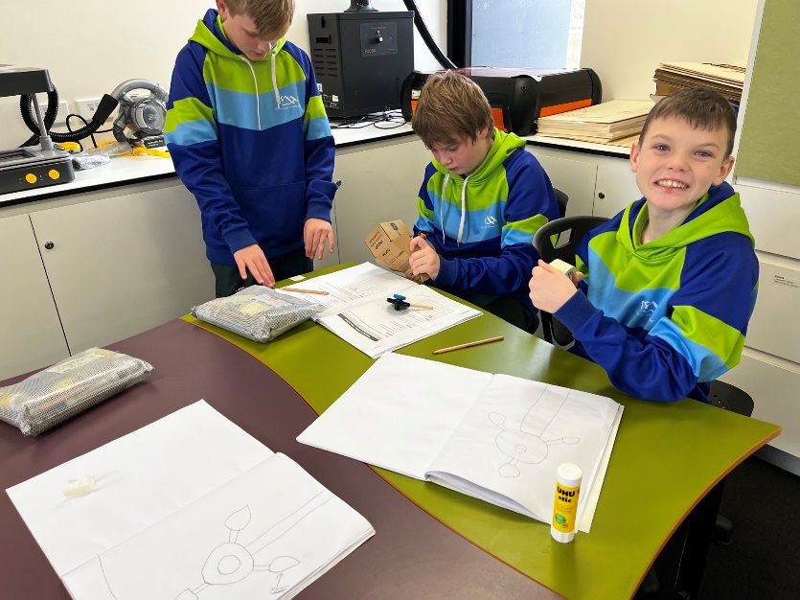
SCIENCE WEEK
The theme this year is Glass-More than Meets the Eye. In Science, classes have been looking at ways glass has changed the world. They have investigated glass through a series of hands-on displays and activities, here are some of the things our students got to see and do. The children were able to see glass prisms refracting light to make a rainbow, we used telescopes to look at the mountain ranges, we examined insects and cloth samples under a microscope, and more. As part of the lessons, Mr Boland showed some short videos that looked at how glass can do some amazing things like Prince Rupert drops and glass bridges. Glass is truly amazing, and our students got to get a taste of what it can do. Ask your child what their favourite thing they saw and used was.
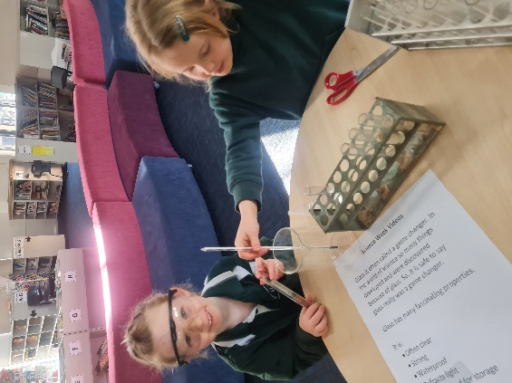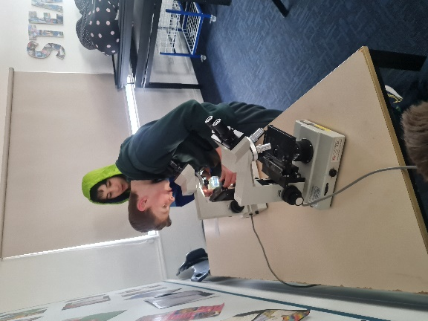
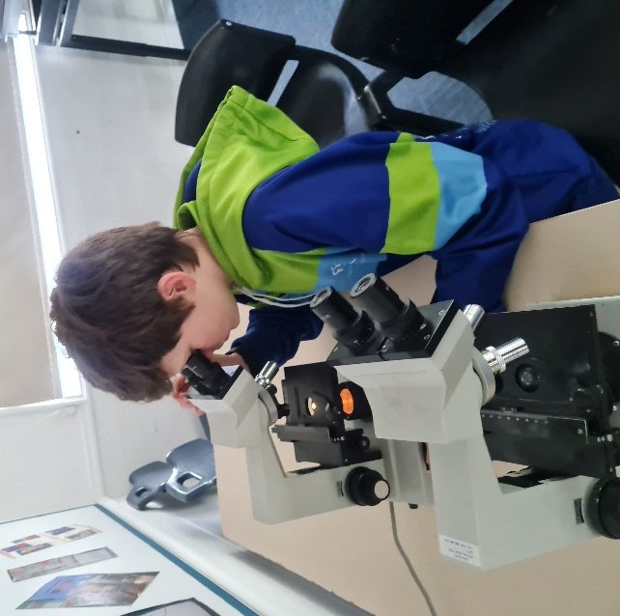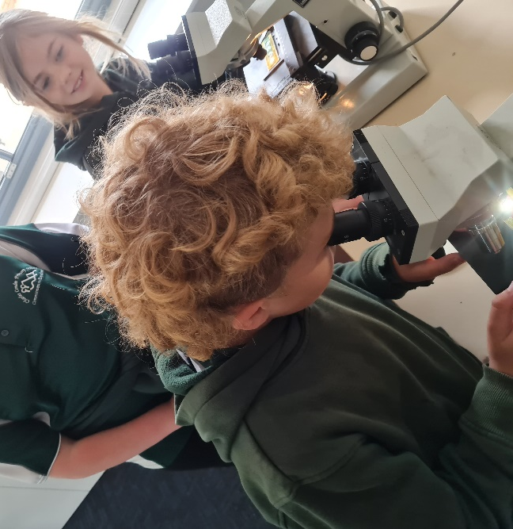

RAPID ANTIGEN TESTS
The Education Directorate are only providing Rapid Antigen Test kits on request, and we are still receiving parent requests for these online via this link: https://forms.gle/PGeNwsUSRwRGjz1Q7
If you would like Rapid Antigen Test’s for your children, please complete the Google form each week via the link above, and these will be distributed to students on Friday afternoons.

BOOK WEEK
This year the Children’s Book Council of Australia Book Week theme is ‘Dreaming with Eyes Open…’ and their shortlist for 2022 contains some fantastic reads for all children. This year, Charles Conder will be celebrating Book Week (Monday, 22 August to Friday, 26 August 2022). The pinnacle of our celebrations is the Book Week Parade. This will take place on Wednesday; 24 August and we encourage students to dress up as their favourite book characters. The parade will take place near the Hall, starting at 9:15am. We would like to extend a welcome invitation to our families to attend the parade as we celebrate all things reading. After the parade you are welcome to come back to our learning spaces to enjoy reading with your child/ren and to join in on some small, Book Week activities. Masks are encouraged whilst attending Book Week celebrations.
In addition to this, students will spend the week enjoying a wide range of literature. This will include secret guest readers during the day, Drop Everything And Read (D.E.A.R) time, a Guess the Teacher competition and a range of in class activities related to high quality books.

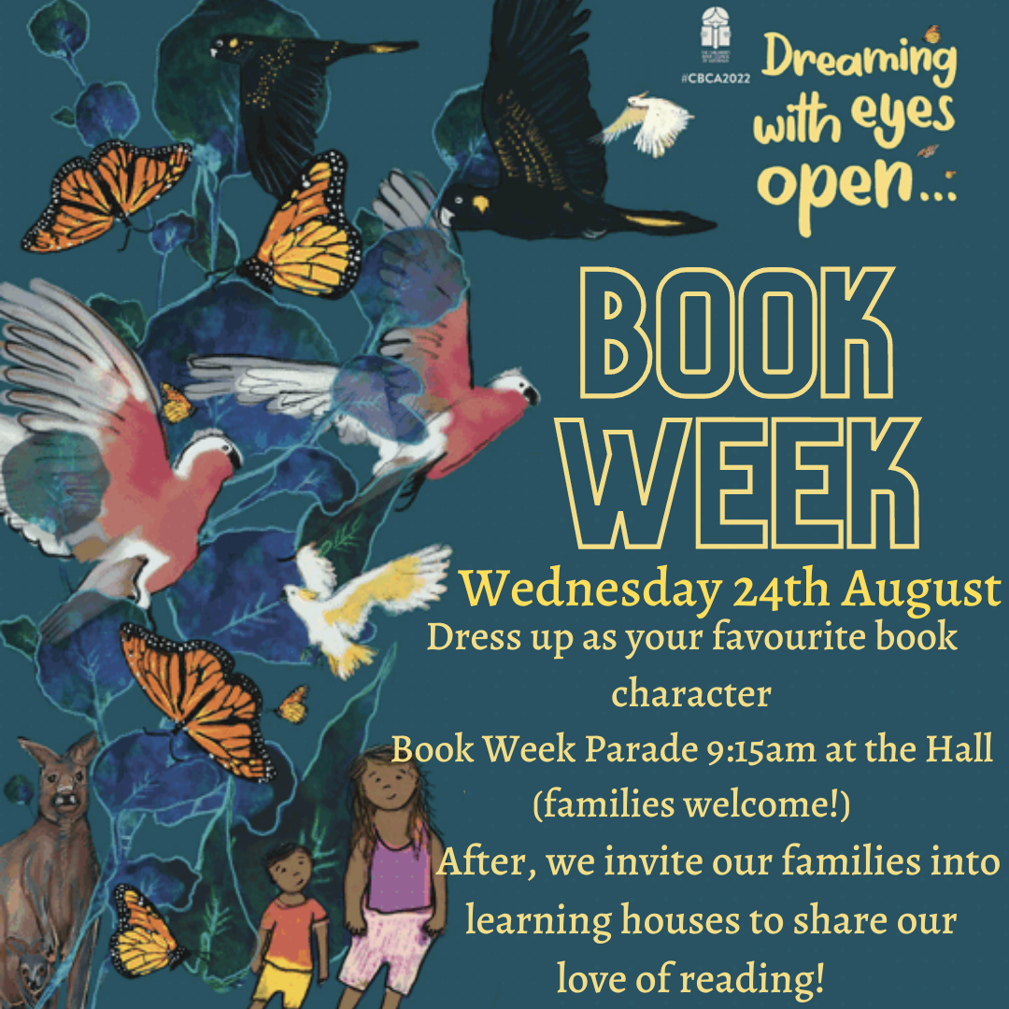

P & C NEWS - FATHER’S DAY STALL

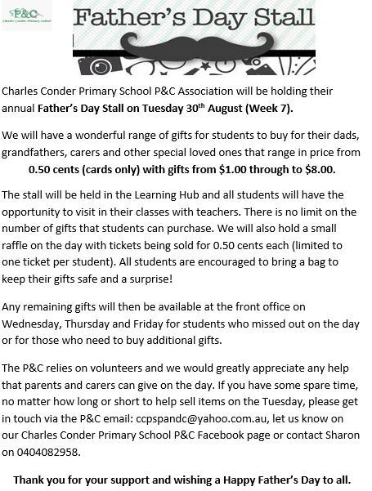

Jason Walmsley
Principal

