FRIDAY, 15 MARCH 2024

SCHOOL BOARD NOMINATIONS & ELECTION
I would like to introduce you to three parents in our school community who are nominating for the parent School Board positions. Please read their personal blurb’s below and keep an eye out for an email on Monday next week with the details and process for an online election.

LISA MACDONALD HOLMES
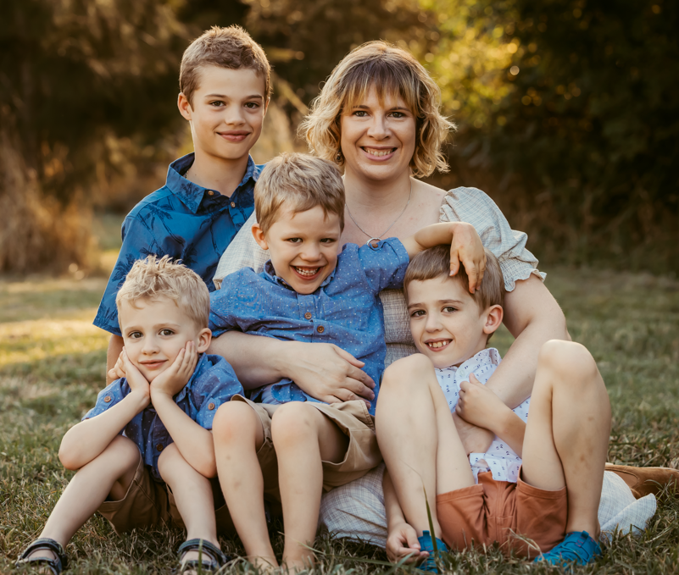

Hi, my name is Lisa, and I am a full-time mother and carer to 4 boys, 3 of which attend Charles Conder primary School. I have been part of the Conder community for the past 6 years and Charles Conder for the past 4 years. I am passionate about our community and our school and how I can support it to shape our young children. 2 of my children are in the small group program in Clement as they have disabilities and I have another in Whatley. I am passionate about school diversity and inclusion, especially for our children that need additional help or need things adjusted in order for them to thrive in a classroom environment. By voting for me I will be able to provide the school board the inside knowledge of what children with additional needs need from their school and how we can help teach all children that children's difference is what makes all children special. Thank you for considering me as one of your parent representatives.

SHARON O’HARA
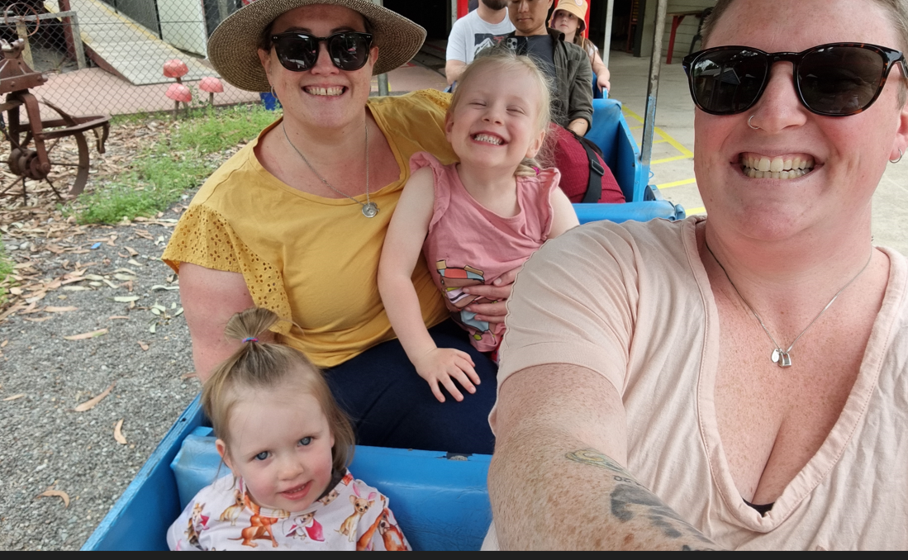

Hello, I'm Sharon. My wife and I are local Conder residents and have two little girls, Neeve and Finnleigh. Neeve started preschool this year and loves 'big school'. We feel lucky to have had our girls at the YWCA childcare centre, who continue to support us and our girls transitioning into Charles Conder Primary School. Through childcare and now school, Neeve and Finnleigh have made wonderful friends, which has allowed us to expand our network and appreciate the people and strengths within our local community. How good is it seeing your child making and being a friend! I have a deep appreciation of the needs of working families, neurodiversity, inclusion, and advocacy. I hope to build a strong relationship with Charles Conder Primary School, supporting the vision of parents, to meet the needs of our kids. I'm so grateful to be able to watch our kids develop, learn, and grow through education and social connection. Thank you for your consideration.

SAMANTHA MALLINSON

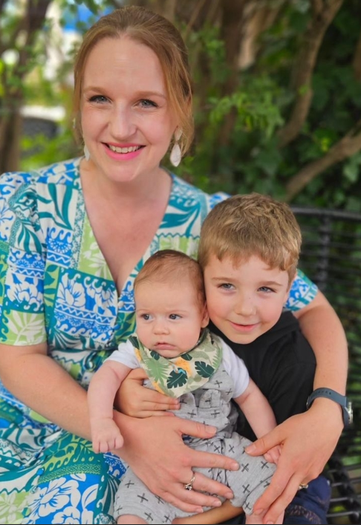

Hi, I’m Sam and have been part of the Charles Conder community since my eldest son started Preschool in 2022. What I love about Charles Conder is the culture – I have always appreciated how the whole faculty happily talks with parents to hear their views, explain their reasoning and consider feedback and am excited to possibly be a part of this. An overview about me:
· My husband (Rob) and I have lived in Lanyon for over 17 years and are happily raising our two boys here - Dom, who is in Year 1 and Nate, who is 5 months old.
· As a newbie school parent, I think I can bring in some fresh views and a different perspective.
· I am the CEO of Adorn Home Staging, a small business I run with my sister and mum, where I look after a great team of people, our budget, HR, client relationships and business strategy.
· I am a bit of a geek when it comes to policy that directly affects people. I love this part of owning my own business and get really excited about procedural innovation, strategy and quality policy.
· I’m an ex public servant, with a background in communication and bringing people together to develop ideas for programs and policies and the best way to communicate this to the public.
I am interested in the why and the how, to ensure we deliver what’s best for our kids. I think the board position could be really interesting, and a way my background and skills could contribute to our school.

NAPLAN – YEAR 3 & 5
This week these cohorts of children have been busily doing some of the literacy assessments. Next week they will be continuing on Monday and Tuesday.

KINDERGARTEN PARENT READING WORKSHOP
It was fantastic to see so many parents come along to learn about the reading process and how to best support their child to develop a love of reading, it was a well organised workshop from Mrs McAlpine and Mrs Rezakhani. It can be an exciting but nervous journey on where to start with your child with their literacy development and we will work alongside our parents to develop your knowledge and skills throughout kindergarten and beyond.

CODE CAMP AFTER SCHOOL SESSIONS
Charles Conder Primary School are looking to partner with Code Camp to offer a weekly STEM program, starting in Term 2. Code Camp After-School allows kids to hone their creative skills and keep practising through weekly sessions over the term! Our fun and engaging content ensures students learn new creative skills in a safe, educational environment. If you would like more information and would like for your child to attend, please click on the link below and find out more and put forward an expression of interest.
codecamp.com.au/as-eoi/CharConPS

P&C CRAZY SOCK DAY & EASTER RAFFLE

