FRIDAY 1 JULY 2022
CELEBRATION ASSEMBLIES
This week we hosted two celebration assemblies for classes in Kindergarten to Year 6. During this time some of our preschool classes were sharing their learning with parents and carers. It was terrific to see so many families come along and have the opportunity to share in the learning that has occurred throughout semester 1, in particular with the focus on our Inquiry learning into caring for our natural world. It was also a time for the Year 6 band to play for an audience which gave them much joy!
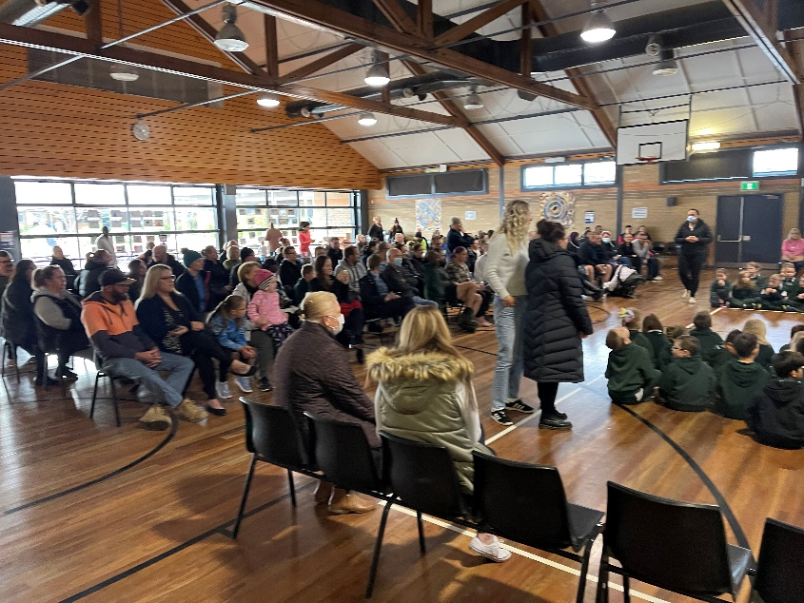
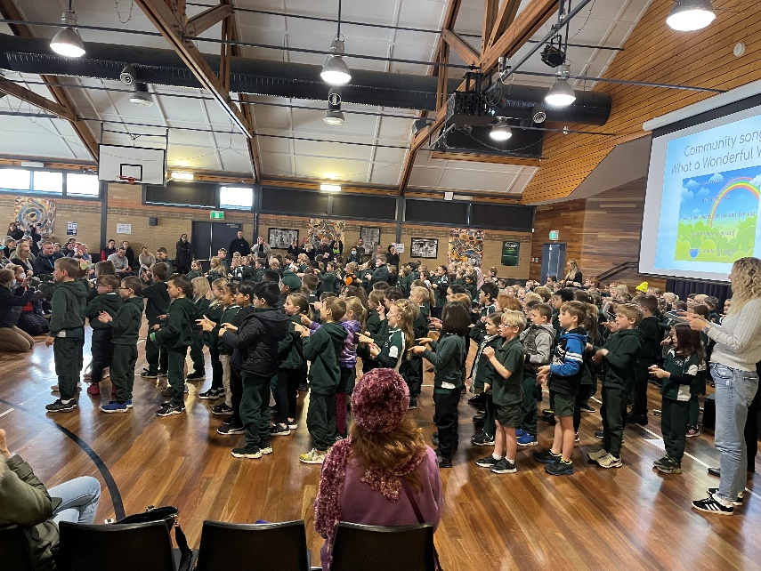
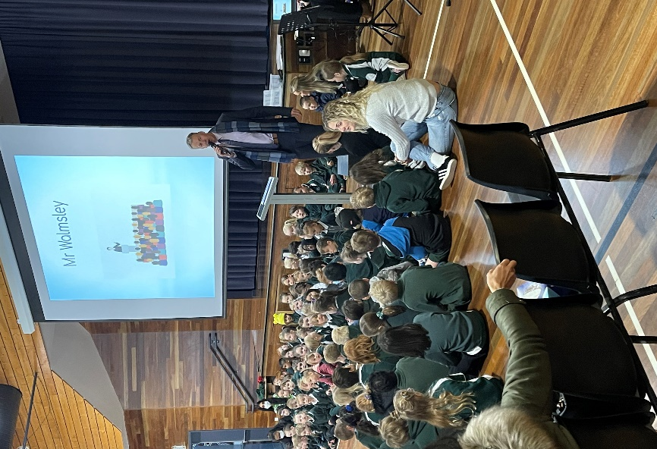

TERM 3 PUPIL FREE DAYS
Thank you for your support in term 2. We are pleased to have transitioned back to regular school activities and have welcomed the easing of some COVID-19 restrictions.
ACT public schools have continued to face workload pressures with higher than usual staff and student absences due to the ongoing presence of COVID-19 and seasonal flu in the community.
This has often meant school leaders and teachers are taking extra classes to cover staff absences. We value and appreciate everyone’s commitment to our students during these challenging times.
We expect these workforce pressures will continue through the colder months of the year.
The Education Directorate is supporting ACT public schools to manage their extra workloads with two staff planning days in term 3. These days will give teachers the time for lesson planning and administrative tasks that they can’t do while on class.
Our school will hold staff planning (pupil free) days on:
- Friday 5 August 2022, and

- Friday 9 September 2022.

Where possible, we ask that students do not attend school on these days. Students who can’t stay at home will be able to attend school and be supervised while undertaking general learning activities.
Please confirm via phone on 6142 0177 or email info@conderps.act.edu.au if your child will be attending school on these days.
If you have any further questions about public school staff planning days, please reach out to our front office and speak with myself.
SCHOOL BOARD UPDATE
The Charles Conder Primary School Board met on Tuesday 28 June. The Board heard from the principal in relation to the school’s enrolment outlook (which remains strong), as we as planned investments in both the Conder and Tharwa preschools to continue to ensure those spaces continue to provide great educational experiences for our children.
The Board was keen to hear a report from teacher representatives Sarah Conway and Rhiannon Freckleton on the value and importance of recent pupil-free planning days. The days have provided our teaching staff with valuable time to plan together as a whole team and ensure they have clarity on cross-curriculum priorities. The planning days have also given our teachers time to dive deeper into the range of data sources we utilise in our school to ensure we have a deep understanding of our students and what will work best for them both from an academic and social/emotional perspective. We look forward to reflection on our school’s performance when we will be reviewed as part of the National School Improvement Tool in August 2022. The review takes place every five years and in 2017 we performed very well at a national level. As always, if you have any questions or anything you would like to raise with a Board member, please email charlesconderps.schoolboard@act.edu.au or speak to a Board member.
Charles Conder Primary School Board Members
Ellen Samuels (Chair), Chris Bignell and Julie Gnjec – Parent and Carer Representatives, Sarah Conway and Rhiannon Freckleton – Teacher Representatives, Jason Walmsley – Principal, Haley Websdane – Business Manager and Secretariat
ATHLETICS CARNIVAL
Our students are looking forward to the Athletics carnival next term and as in past years, our Athletics Carnival will be held over 2 days. Our main event will take place on Friday, 22 July on our school oval. This will be a whole school event and all students from Pre-School to Year 6 will participate. The track events (800m, 200m, 100m, 70m) will be held on this day.
Our field events (Long Jump, Shot Put, Discus) will take place on Friday, 29 July at the Banks oval. The carnival for our field events will be only open for students aged 10 years and above. Permission notes for our carnival at Banks Oval will be handed out early next term.
All parents are welcome to attend either day. Our traditional family races will be taking place on Friday, 22 July at 9.15am and we hope to have another strong turn out to enjoy the festivities. A schedule of events can be found attached to today’s newsletter. On the day of our main event, we would love to have parents assist us throughout the day. Please contact me if you are interested, no expertise is needed, any support will be greatly appreciated. If you have any questions about our carnivals, please don’t hesitate to contact me Jonathon.tucker@ed.act.edu.au
Jon Tucker
Sports Coordinator
SEESAW
This is our communication App that we utilise to communicate with families on a regular basis. All our students in the school have personalised goals and learning that students are doing, and it is often shared to family members on this App. We would ask if you don’t have access, please contact the front office so the teachers can organise for you to be connected.

Jason Walmsley
Principal

